Nutrition and Cost Analysis of Chicken Stir Fry—4 Servings
Performance Objective 8—Fresh vs. Frozen Produce

Food | Cost per Package | Cost per 4 Serving Recipe | Time: Prep + Cooking | Totals
1 bouillon cube | $0.94—8 cubes | $0.12
1 c hot water | n/a
2 TB corn starch | $1.28—16 oz. (454 g) | $0.05
1/4 c soy sauce | $2.28—15 fl. oz. (444 mL) | $0.31
1/4 tsp minced garlic | $3.76—3 oz. | $0.03
1 chicken breast | $12.22—5 lb. | $1.47 | Prep time about 5 minutes
1-1/2 c instant brown rice | $2.00 per 14 oz. box | $0.68 |  | Subtotal: $2.66
1-1/2 c water | n/a |  | Rice cooking time 10 minutes | About 15 minutes
Vegetables:
1 c broccoli | $2.48—12 oz. florets pkg | $0.83
1 carrot—abt 1/2 cup | $0.68—16 oz. raw carrots | $0.09
1 celery | $1.36—16 oz. | $0.12
1/4 lg onion | $1.50—3 lb bag | $0.25 |  | Vege subtotal: $2.79
1/4 c. water chestnuts | $1.02—8 oz can (abt. 1/2 c) | $0.51 |  | Total recipe $5.45
1/4 c. snow peas | $2.48—8 oz. pkg | $0.99 | 10 + 15 = 25 minutes | Total recipe about 30-40 minutes
FROZEN VEGETABLES
1/4 pkg Birds Eye Oriental Stir Fry—58 oz | $5.77 | $1.45 |  | Total recipe = $2.66 + $1.45 = $4.11
--Broccoli, sugar snap peas, carrots, water chestnuts, peppers, mushrooms, baby corn |  |  | No prep time for vegetables + 4 minutes in microwave + 2 minutes in wok = 6 minutes | Total recipe using frozen = about 20 minutes
Innovasion Chicken Fried Rice—18 oz. | $3.97 | $3.97 for 3 servings | Microwave 2 minutes, turn and 4 minutes | About 6 minutes
It is difficult to estimate time for these two recipes, but the advantages to frozen vegetables are: (1) no prep time washing, paring and chopping, (2) because they are blanched before they are frozen the cooking time is also shorter, (3) frozen vegetables last longer in than fresh so there is less waste, (4) total recipe cost is less.

Chicken Stir Fry:
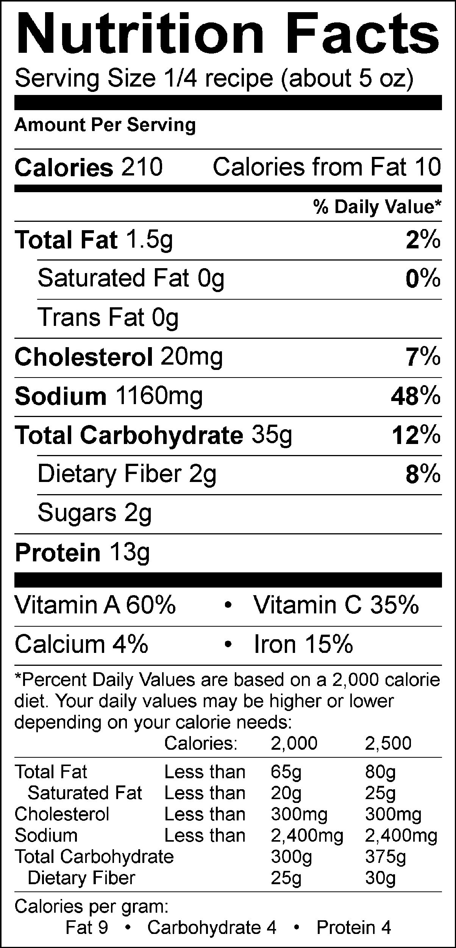

Chicken Stir Fry—Frozen Vegetables 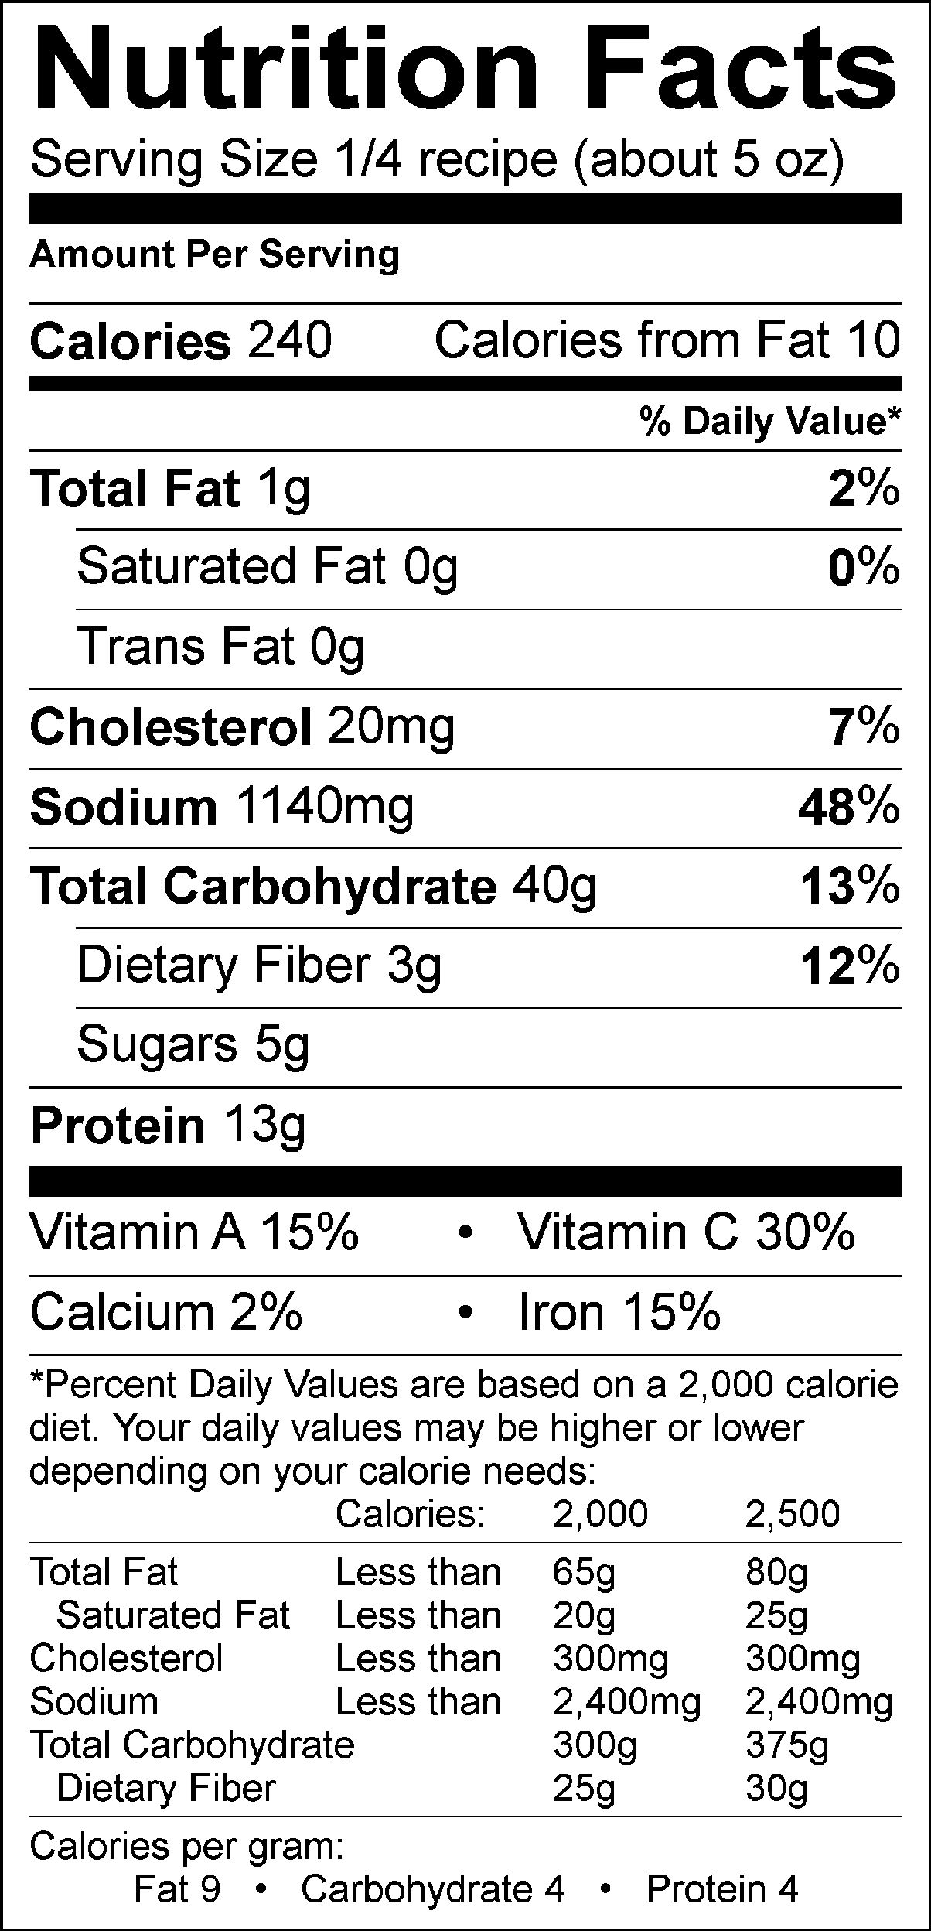

To go totally convenience food, here is the Innovasion label:

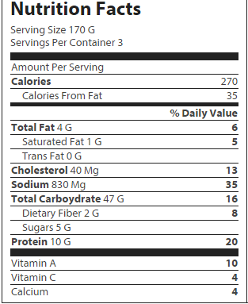

Birds Eye Oriental Stir Fry Vegetables:
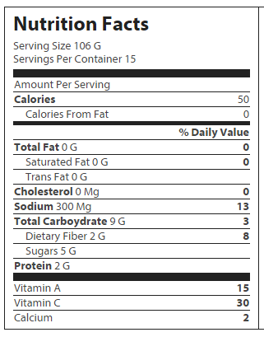

Chicken Stir Fry—Fresh Vegetables

Base: Vegetables:
1 bouillon cube 1 stalk of celery (about 3/4 c)
1 c. hot water 1/4 of a large onion
2 Tbsp. corn starch 1/4 c. water chestnuts
1/4 c. soy sauce 1/4 c. snow peas (or sugar snap)
1/4 tsp. minced garlic 1 cup or 1 small bunch of broccoli
1 chicken breast, bite-sized pieces 1 carrot (about 1/2 cup)
1-1/2 c instant rice (brown is best)
1-1/2 c water (for the rice)
Pre-Heat
1. Unplug the microwave in your kitchen unit, and plug in the electric skillet. Pre-heat the electric skillet to 375° with the lid on. Be sure that it is not touching anything around it, (like the microwave or blender). Also, be careful that you don’t burn yourself.

Vegetables
- Wash and cut up: broccoli, carrot (remember to peel first), celery and onion into bite-sized pieces. Cut the water chestnuts in half. Wash and trim snow peas. Keep your vegetables separated in bowls or custard cups. Do not combine them all together.
- Add only the carrots and broccoli to the electric skillet and cook for about 5 minutes or until tender with the lid off. Add celery, onion, water chestnuts and snow peas and cook for an additional 10-15 minutes, or until all vegetables are tender. Add about 1/4 c. of water to the vegetables if they start to stick or burn while cooking. Stir the vegetables constantly.

Chicken
- Cut chicken into bite-sized pieces. Add chicken pieces to a large skillet on the stovetop and cook over high to medium-high heat until cooked through and golden brown. When the vegetables are finished cooking, add the chicken to the electric skillet.

Sauce
- In a small saucepan, combine 1 c. hot water and bouillon cube and bring to a boil. Stir until bouillon cube is dissolved and then REMOVE FROM HEAT.
- In a cereal bowl, combine soy sauce and cornstarch. Stir with a fork until completely dissolved and smooth. Add garlic to the soy sauce mixture. Slowly add the soy sauce mixture to the saucepan with the bouillon. Put the saucepan back on the heat and whisk the sauce mixture over medium low heat until it thickens and turns dark brown. Remove from heat and add sauce mixture to the vegetables and chicken and stir until all ingredients are coated.

Rice
- In a small glass bowl, combine instant rice and 1 ½ c. water. Cover with plastic wrap. (Remember to poke a hole in the top to allow some steam to escape.) Cook in the microwave for 5 minutes. Allow to stand for 2-4 minutes or until all water is absorbed. Watch the rice carefully. You may need to replace the plastic wrap a couple of times during the cooking process.

Putting It All Together
- Divide the rice evenly into the take-away containers or paper plates. Then, evenly divide the vegetable mixture on top of the rice. Eat and enjoy.

ADJUSTMENT TO RECIPE FOR FROZEN VEGETABLES:
Vegetables
Ignore steps 2 and 3. Go ahead and do the chicken. While chicken is cooking, microwave the frozen vegetables for half the recommended time, then add them to the electric skillet, stirring frequently until they are thawed and tender. Do NOT use sauce packet.

