Nutrition and Cost Analysis of Chicken Pot Pie
Performance Objective 8: Canned vs. frozen/fresh

Easy Chicken Pot Pie | Cost per Package | Cost per 4 serving recipe | Time: Pre + Cooking | Totals
Crust:
1 c flour | $2.36 for 5-pound bag—75 fourth-cup servings at $0.16 per cup | $0.16
1-1/2 tsp baking powder  (6.9g) | $2.13 for 10 oz can (284 g)  1/2 tsp = 2.3 g | $0.06
1/2 tsp salt  (3 g) | $1.12 for 26 oz (737g)  1 tsp = 6 g | $0.01
1-1/2 tsp sugar  (6.3 g) | $1.88 for 2 lb  (970 g)  1 tsp = 4.2 g | $0.02
3 TB dry milk  (24 g) | $3.98 for 9.6 oz. (276g)  1 TB = 8 g | $0.35
1/4 c shortening  (48 g) | $4.98 for 48 oz (136 kg)  1 TB= 12 g | $0.01
1/2 c water | n/a
2 TB beaten egg | $2.68 per dozen  1 whole egg = 3 TB | $0.23 | Prep about 15 minutes | Cost for crust = $0.84
Convenience crusts
Refrigerator Biscuits  (put all on top of pie) | $1.68 for 8 biscuits | $1.68 | Prep about 5 minutes | Cost for biscuit crust = $1.68
Frozen Pie Crusts | $2.00 for 2 count, 12 oz.  Pie crusts for 9” pans | $1.00 | Prep about 3 minutes | Cost for pie crust = $1.00
Filling
1 cooked chicken breast, diced | $2.49 per pound raw—1 chicken breast = abt 118 g—about 1/4 pound | $0.62 | Prep = 10 minutes to cook and dice
1 Chicken breast, cooked and shredded | $2.74 for 12 oz. can (336 g) | $0.92 for 1/3 of can | No significant prep or cook time
1/3 cup (5.3 TB) Soup or Sauce (SOS) Mix—cooked with 1-1/4 c water | $4.16 to make 3-1/4 c dry mix (303 g)  1 TB = 6 g | $0.44 | Prep + Cook = 5 minutes | Cost for chicken and SOS sauce = $1.06  Cost for canned chicken and SOS = $1.36
Convenience sauce: 1 can cream of chicken soup mixed with 1 can of water | $1.25 for 10-1/4 oz (305g) | $1.25 | Prep + Cook = 5 minutes | Cost for chicken and soup sauce  = $1.87  Cost for canned chicken and soup sauce = $2.17
--Fresh vegetables for filling (abt 257g)
1/2 c fresh Sugar Snap peas, shelled or dice the peas in the pod or use as-is  (49g) | $4.68 for 16 oz.  (454 g)  1 c chopped = 98 g | $0.51
1/4 c corn—cut off of cob  (1 c kernels = 154 g)  (38.5 g) | $0.41 per medium ear of corn  (90 g) | $0.41 (will use less than half of the ear)
1/2 of stalk of celery  (1 large stalk = 64 g)  (32 g) | $1.15 per pound  (454 g) | $0.09
1/2 of potato, diced (medium potato = 213g)  (107 g) | $0.85 per pound (454 g)  1/2 cup diced = 75 g | $0.21
1/2 of carrot, sliced—about 1/4 cup  (30.5g) | $0.53 per pound (454 g)  1 cup slices = 122g | $0.04 | Prep time about 15 minutes | Cost for Raw vegetables = $1.26
--Frozen vegetables for filling
Green Giant Garden Vegetable Medley  --potatoes, sugar snap peas, red peppers and herbs  (use whole package) | $1.48 for 8 oz (226 g)  1 c serving = 99 g  (Package has two servings) | $1.48
1/4 c Frozen corn  (1 c = 141 g)  (35.25g) | $1.23 for 12 oz. (340 g) | $0.13
1/4 c Frozen carrots  (32g) | $1.23 for 14 oz. (397 g)  1 c slices = 128g | $0.10
(no frozen celery) | n/a |  | Prep time about 5 minutes | Cost for frozen vegetables = $1.71
Convenience mixed frozen vegetables:
Pictsweet Vegetable Soup Mix  --tomatoes, potatoes, corn, carrots, butter beans (lima beans), okra, green beans, onions, celery  (Use about 1/3 of the package—273g) | $2.38 for 28 oz. (820 g) | $0.80 | Prep time about 3 minutes to open package and dump in | Cost for total frozen convenience  = $0.80
Canned vegetables:
1/4 c canned sliced carrots  (36.5 g) | $0.98 for 14.5 oz. (284 g)  1 c = 146 g | $0.13
1/2 c canned peas  (85 g) | $3.28 for 4-15 oz. cans ($0.82 per can)  (1 can = 313g) | $0.23
1/4 c canned corn  (41 g) | $2.75 for 4-15 oz. cans)($0.69 per can)  (1 can = 298g) | $0.10
(no canned celery) | n/a
1/2 c Canned potatoes  (about 90 g) | $0.68 for 15 oz. sliced potatoes  (425g) | $0.15 | Prep time about 10 minutes. | Cost for canned vegetables = $0.61

Differences in Ingredients

Ingredients | Price Differences | Prep Time Differences
Raw Chicken vs. canned chicken $0.62 vs. $0.92 | Canned chicken $0.30 more | About 10 minutes more with raw
Scratch crust vs. biscuits  $0.84 vs. $1.68 | Biscuits twice as much | Scratch about twice as long
Scratch crust vs. frozen pie crust $0.84 vs. $1.00 | Pie crust $0.16 more (19% higher) | Scratch about three times as long
Biscuits vs. frozen pie crust  $1.68 vs. $1.00 | Biscuits $0.68 more (68% higher) | No difference
Fresh vs. frozen vegetables  $1.26 vs. $1.71 | Frozen $0.45 more (36% higher) | Fresh take about three times as long to prepare
Fresh vs. convenience frozen  $1.26 vs. $0.80 | Fresh $0.46 more than convenience frozen (58% higher) | Fresh take five times longer than convenience frozen
Fresh vs. canned  $1.26 vs. $0.61 | Fresh $0.65 more (twice as much as canned) | Fresh takes at most twice as long as canned
Frozen vs. convenience mixed frozen  $1.71 vs. $0.80 | Frozen is $0.91 more than convenience frozen | Frozen is slightly longer than one bag of convenience mixed frozen
Frozen vs. canned  $1.71 vs. $0.61 | Frozen is $1.10 more than canned (almost three times the price of canned) | Canned takes slightly longer to open than plastic bags
Convenience mixed frozen vs. canned  $0.80 vs. $0.61 | Convenience mixed cost $0.19 more than canned | Canned takes slightly longer to open than one plastic bag
SOS Mix vs. Cr. of Chicken Soup $0.44 vs. $1.25 | Soup is $0.81 more than the SOS mix (65% more) | Prep time about the same

Nutrition Label Comparisons
Fresh Vegetables | Frozen Vegetables | Canned Vegetables
Fresh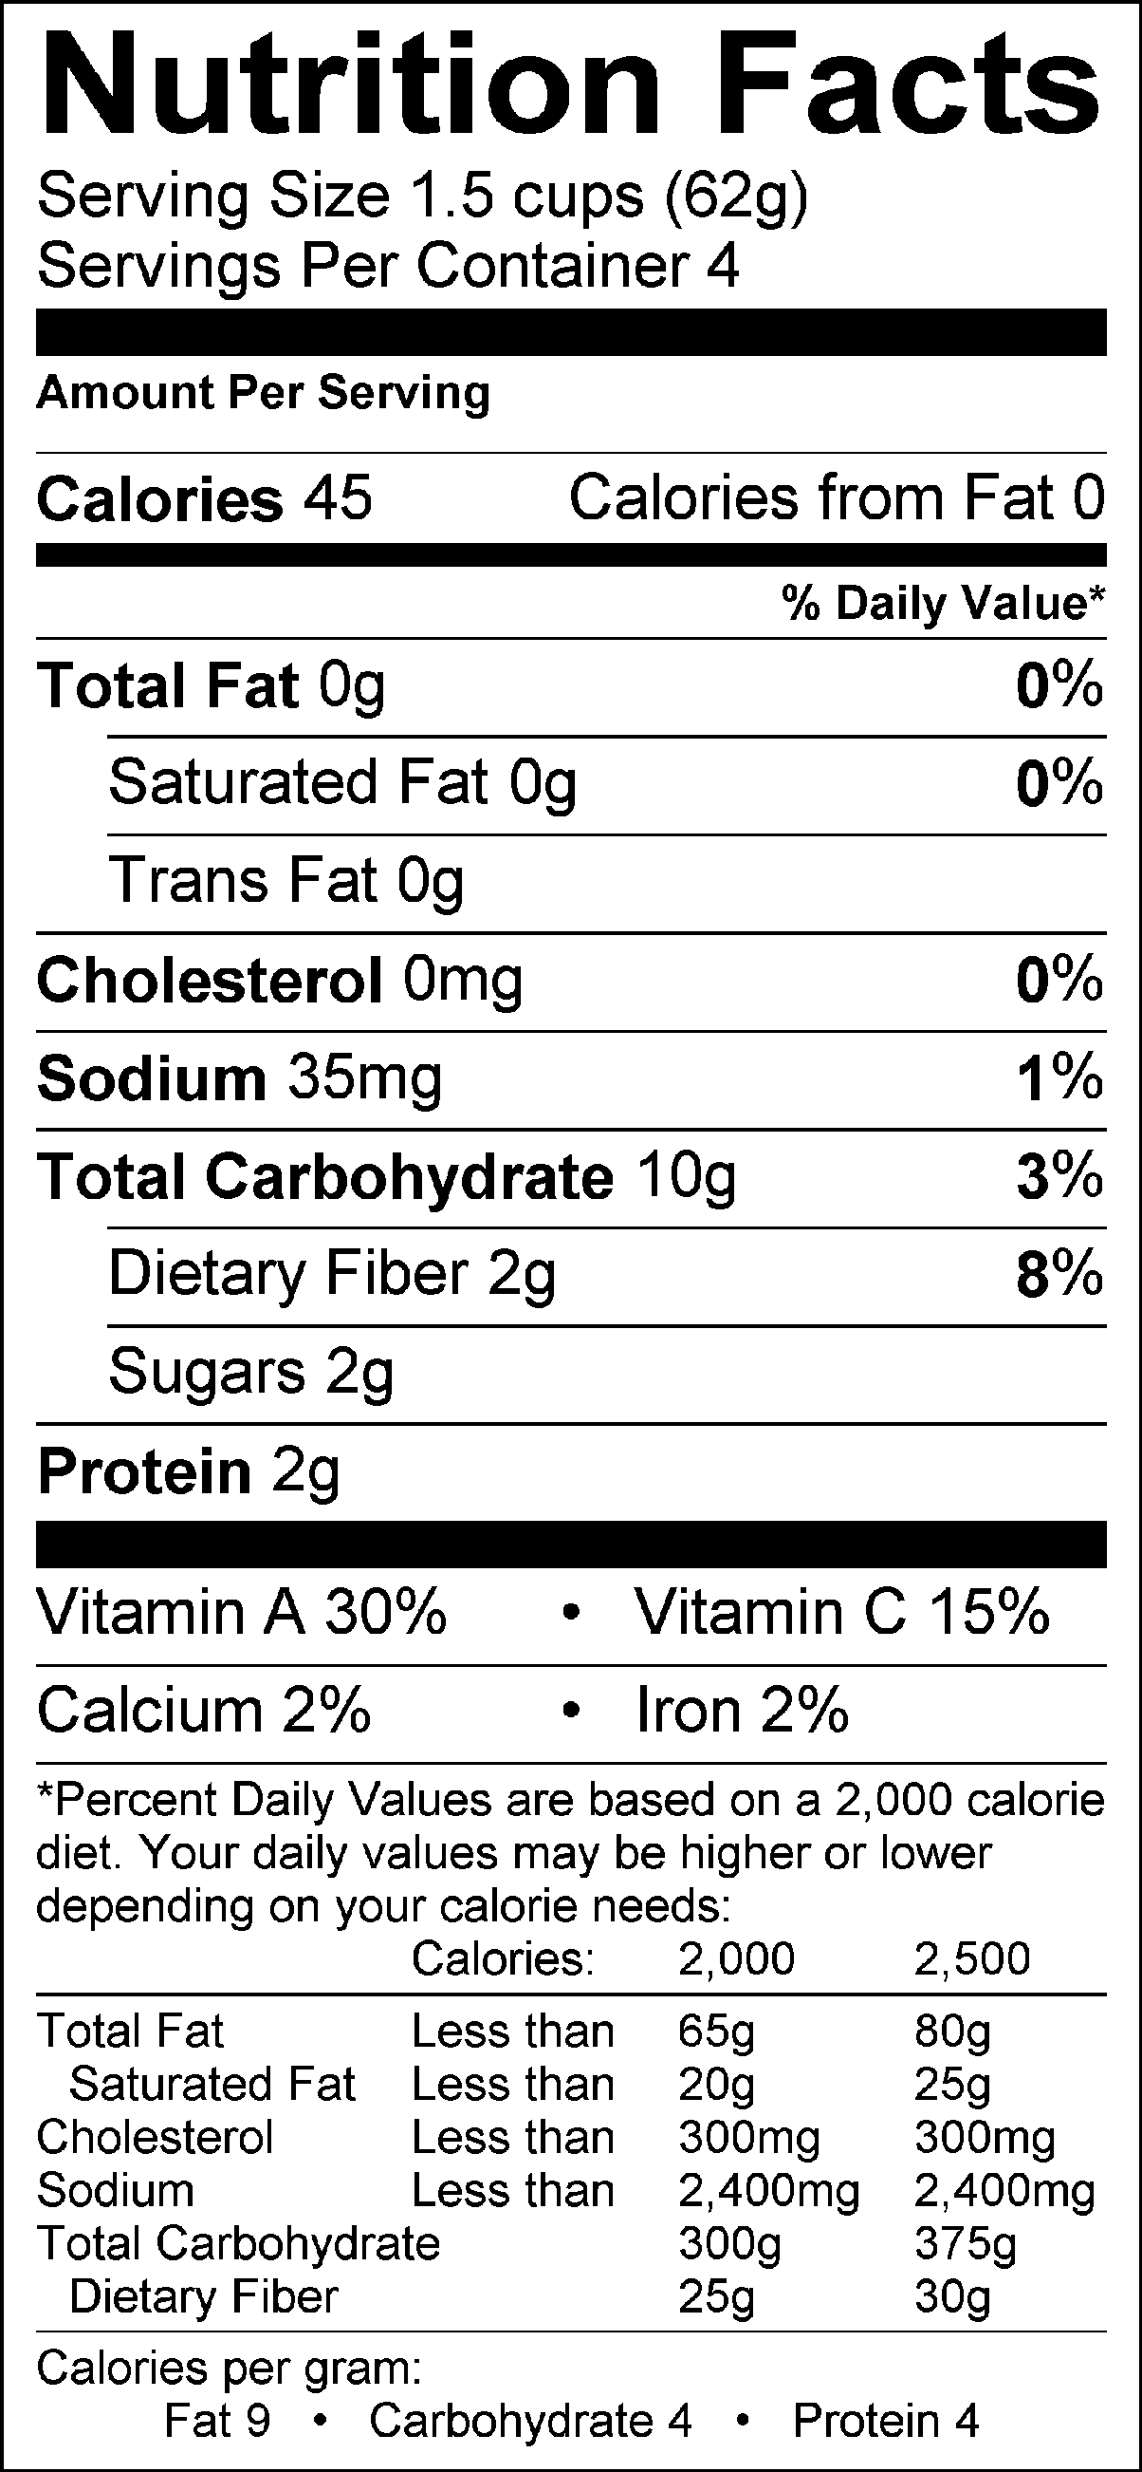 | Frozen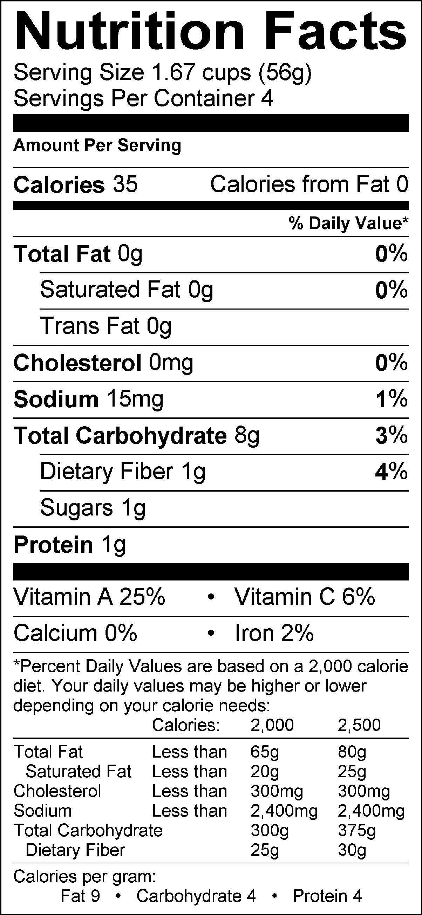 | Canned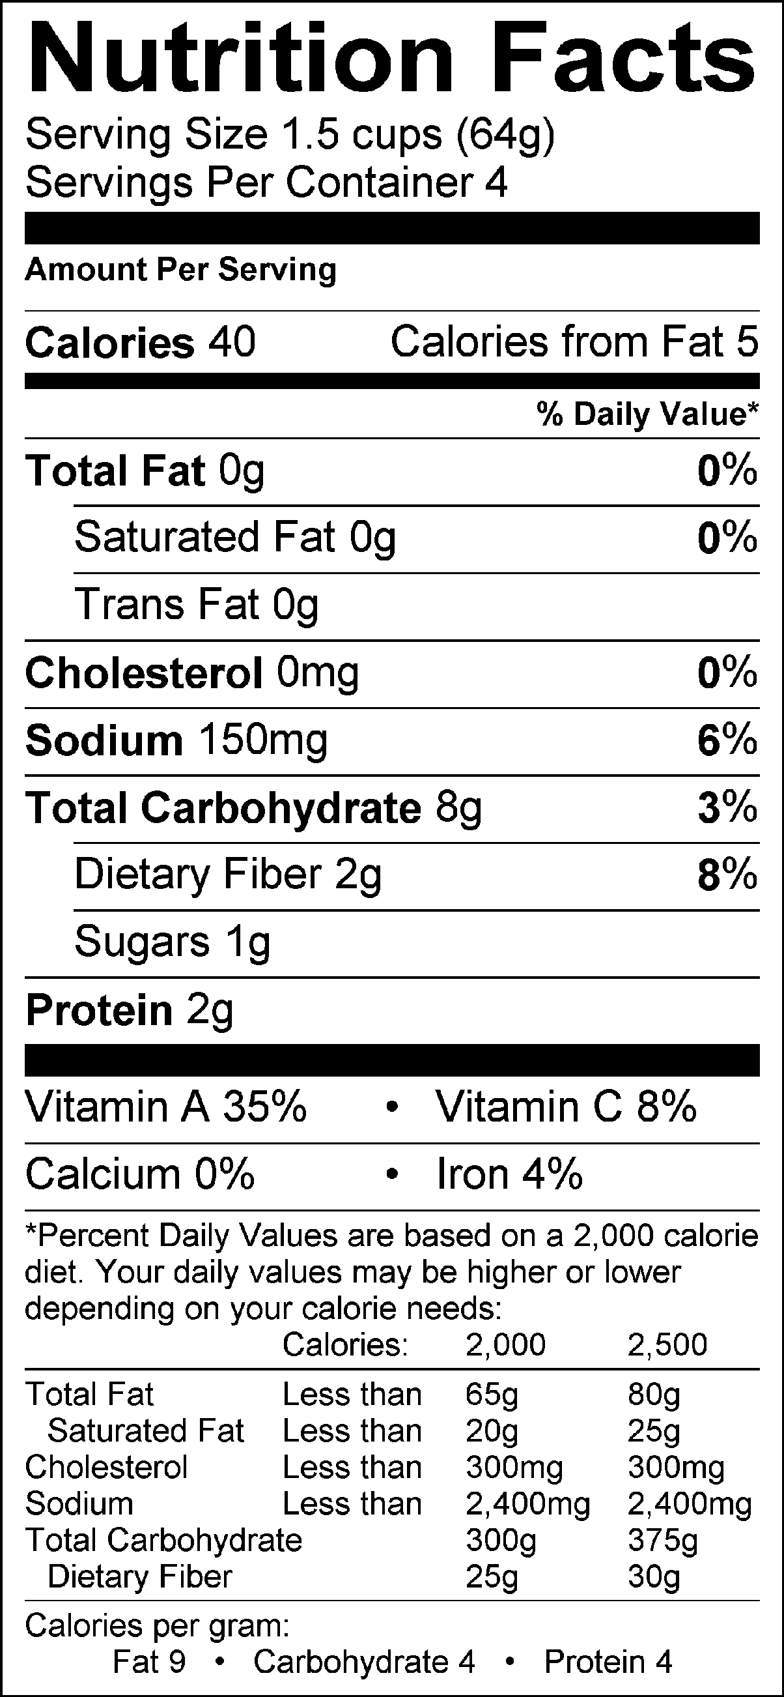
Easy Chicken Pot Pie Topping  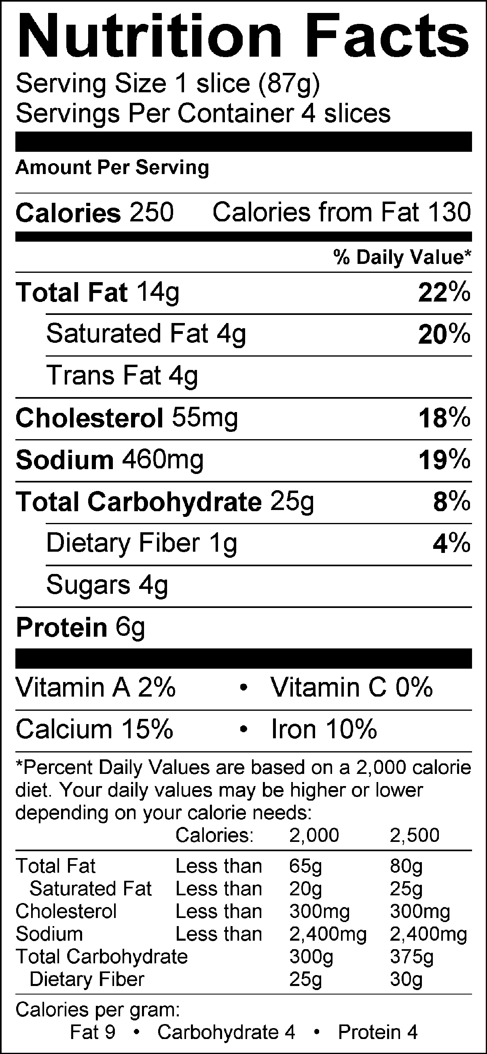 | Refrigerator Biscuits  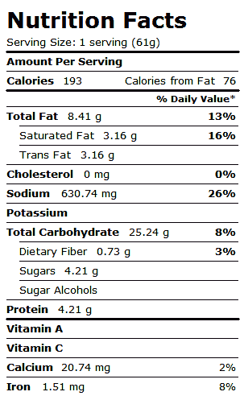 | Frozen Pie Crust  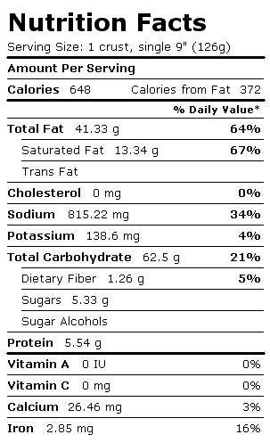
SOS Sauce Mix—amount of 1 can of soup  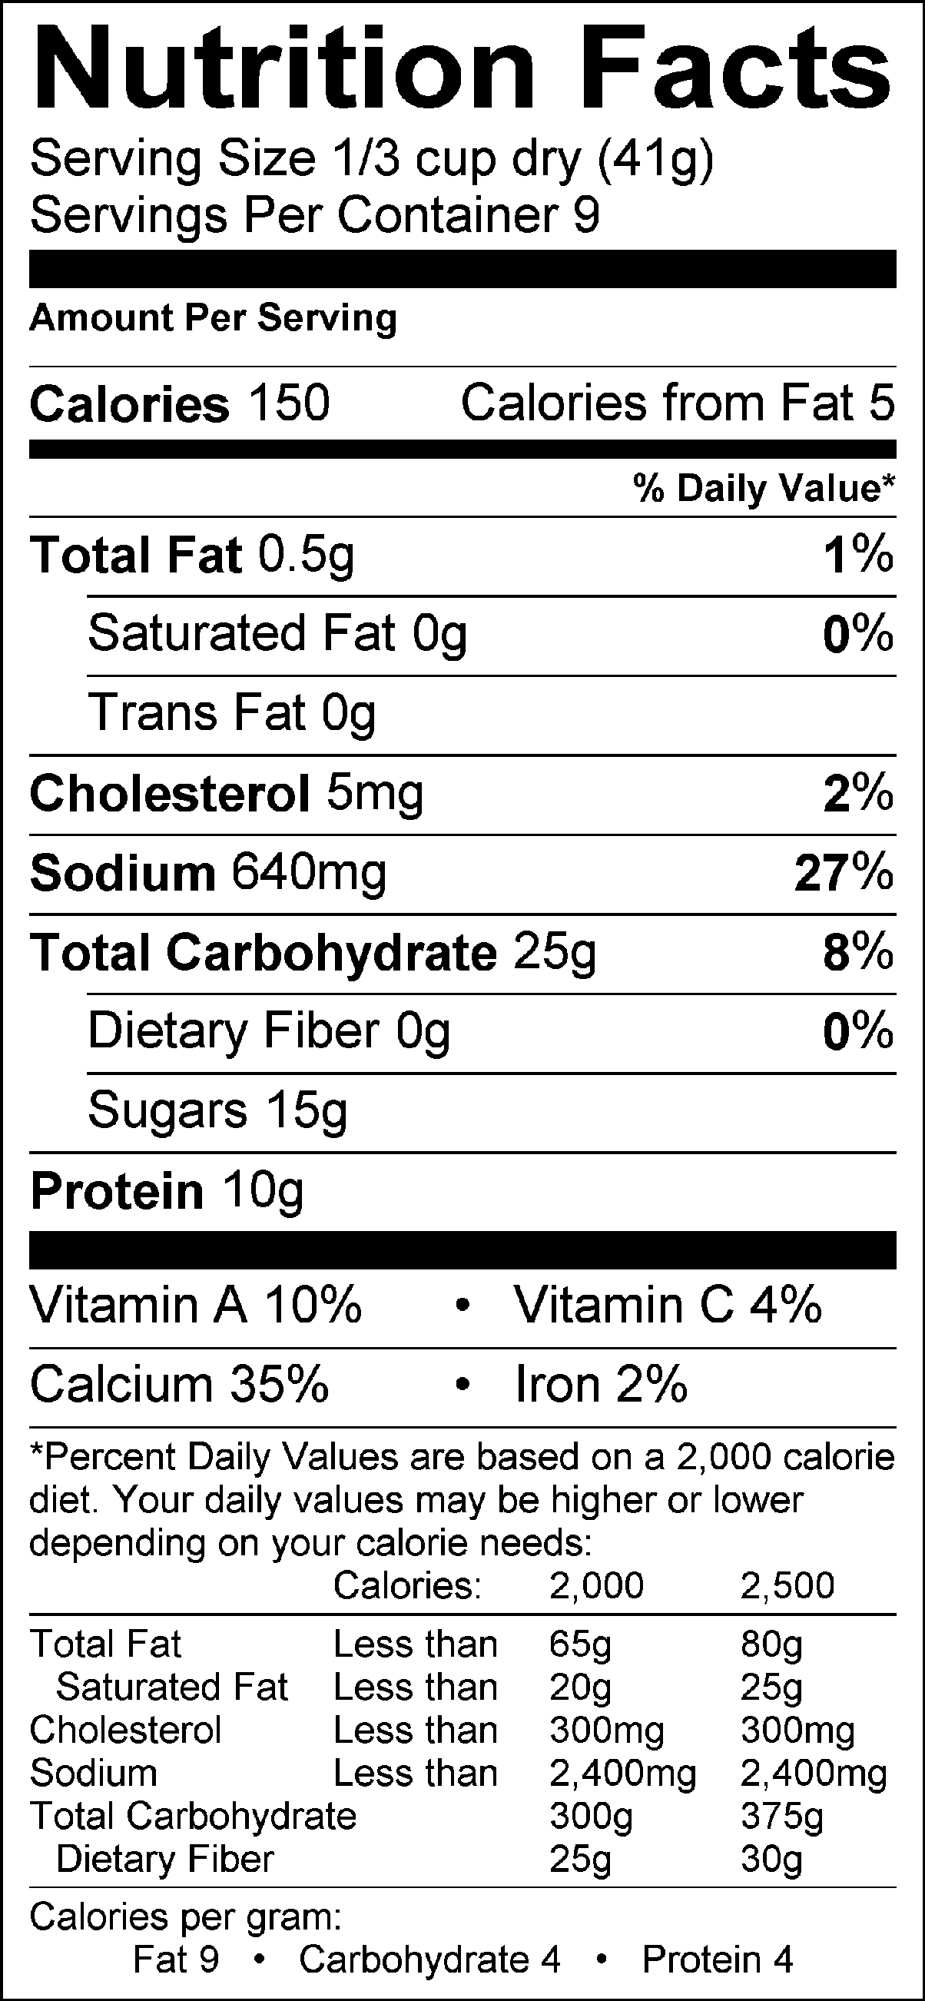 | Cream of Chicken Soup for Sauce—entire can  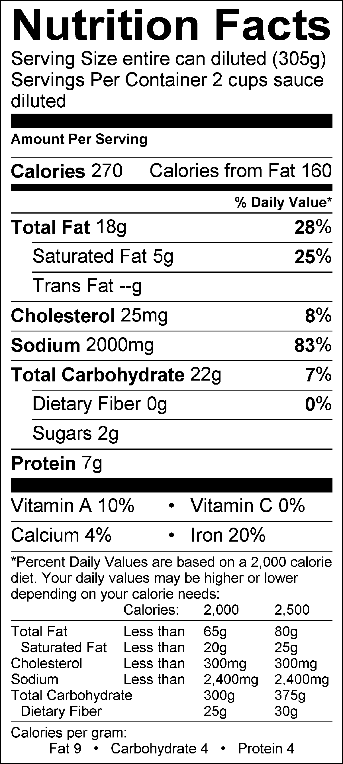 | Cream of Chicken Soup for Sauce—one person’s share  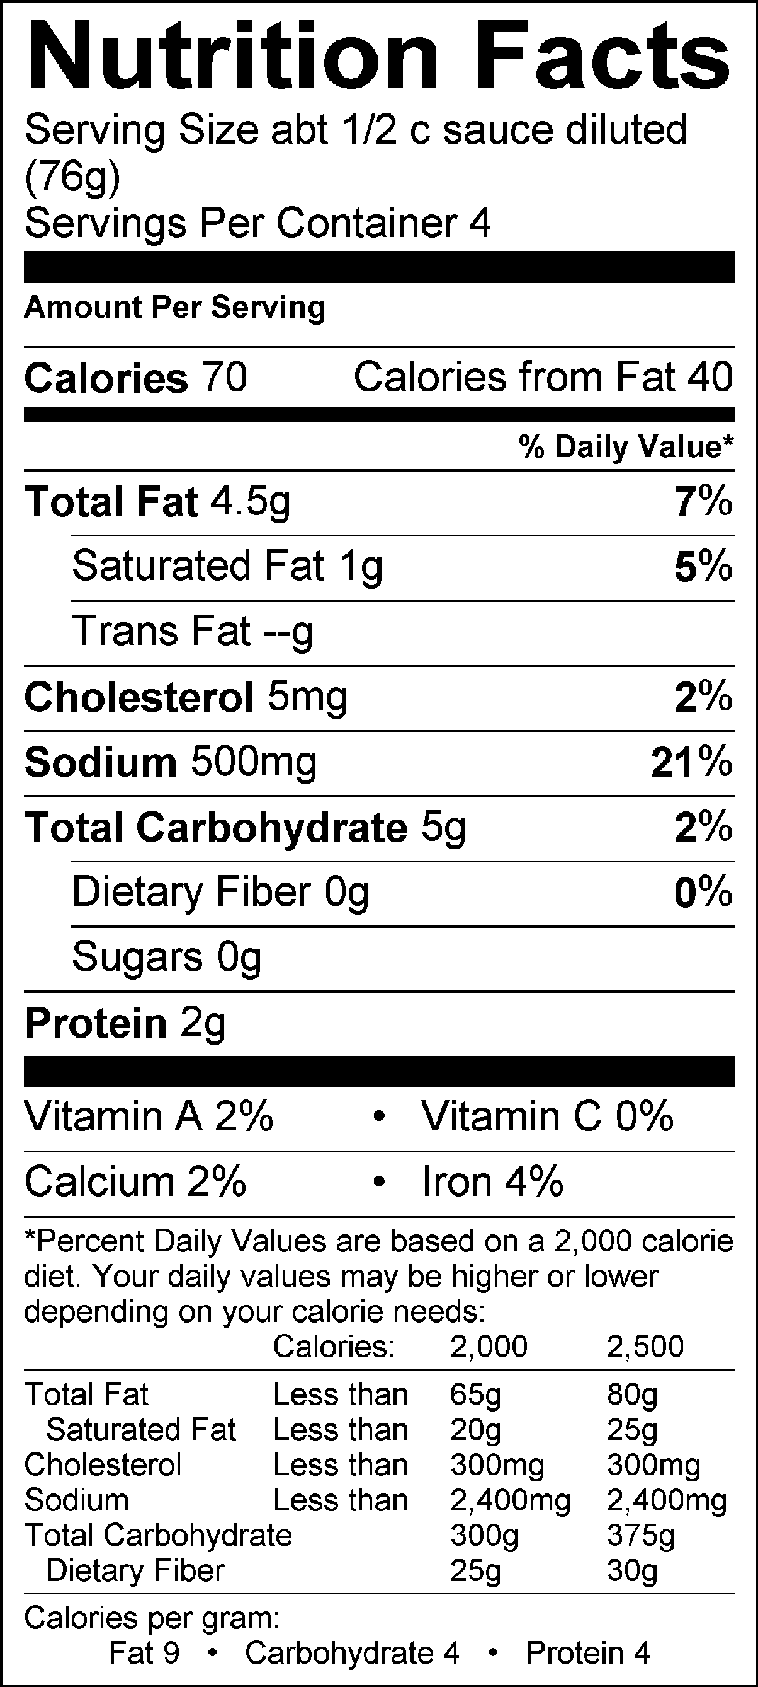

Chicken, raw, 100 g | Chicken, canned, 100 g
Calories: 148 kcal | Calories: 165 kcal
Protein: 21.26 g | Protein: 21.77 g
Total Lipids: 6.32 g | Total Lipids: 7.95 g
Carbohydrates: 0 | Carbohydrates: 0
Sodium: 79 mg | Sodium: 138 mg
Potassium: 251 mg | Potassium: 503 mg

Overall analysis: The nutrition value differences for fresh, frozen and canned produce are minimal. Cost for canned produce is much lower, but the taste of fresh and frozen may encourage the higher cost of fresh or frozen. Time of preparation is minimal for frozen or canned vegetables, so if speed is important, then fresh produce takes too long.

On the crust, the scratch crust is cheapest and if the time is available, is also the lowest in sodium. The pie crust is by far the least nutritious.

For the sauce, the SOS mix is cheapest and also the most heart-healthy. The soup is very fast, but has nearly three times the sodium and 25% more fat.

Canned chicken is only $0.30 more than raw chicken, so canned chicken could be a good choice for the pot pie because it is much faster. The nutrition differences are minimal with only sodium being higher (but still fairly low) in the canned, and potassium being twice as much in the canned (which is a good).

Taste and time will be the determinants on how the chicken pot pie is to be made!

Easy Chicken Pot Pie

Topping Ingredients:
1 cup flour 3 TB dry milk
1-1/2 tsp baking powder 1/4 cup shortening
1/2 tsp salt 1/2 cup water
1-1/2 tsp sugar 2 TB beaten egg

Topping Directions:
Preheat oven to 400º F. In a small mixing bowl, combine flour, dry milk, baking powder, salt, and sugar. Cut shortening into flour mixture with pastry blender until mixture resembles fine crumbs. Stir in water and beaten egg. Hold in mixing bowl.

Filling Ingredients:
1 chicken breast, small diced & cooked 1/2 stalk celery, chopped
1/2 carrot (sliced) 1/2 potato, diced
1/2 cup frozen peas 1/4 cup corn
1/3 cup Soup or Sauce Mix 1-1/4 c water

Filling Directions:
Prepare vegetables and chicken. To prepare soup or sauce mix, combine with water in small sauce pan. Mix all ingredients together. Place mixture in an ungreased pie plate, pouring topping mix over filling. Bake 30 minutes at 400º F or until topping is golden brown.

Wrap Up Questions:

1. What way did we measure 2 Tbsp of egg and why did it have to be done that way?

2. What ingredients are high in vitamins and minerals in this dish?

3. What vitamins and minerals are present?

