Nutrition and Cost Analysis of Fruit Pizza
Performance Objective 8: Canned vs. frozen/fresh

Fruit Pizza  Dough: | Cost per Package | Cost per 8 serving recipe (1 pizza pan) | Time: Prep + Cooking | Totals
1 egg | $2.68 per dozen | $0.23
1/4 c butter  (half a stick) | $2.89 for 1 lb (four 1/2 cup sticks) | $0.37
1/2 c sugar  (100 g) | $1.88 for 2 lb (907 g)  1 c = 200g | $0.21
1/4 c sour cream  (57.5 g) | $1.68 for 16 oz. (1 lb. or 454 g)  1 c = 230 g | $0.22
1/4 tsp baking soda  (1.15 g) | $0.58 for 8 oz. (227 g)  1 tsp = 4.6 g | $0.01
1/8 tsp salt  (0.75 g) | $1.12 for 26 oz. (737 g)  1 tsp = 6 g | $0.01
1/4 tsp vanilla  (1.05 g) | $2.16 for 2 oz.  (57 g)  1 tsp = 4.2 g  1 oz = 6 tsp | $0.06
1-1/4 c flour  (156.25 g) | $2.36 for 5 lb bag (2.268 kg)  1 cup = 125 g | $0.17 | Prep: 5 minutes + 10-12 minutes cooking | $1.28
Frozen sugar cookie dough | $2.50 for 24 cookies—16.5 oz. (468 g) | $2.50  Use entire package for one crust | Prep: about 5 minutes to roll out +10-14 minutes cooking time | $2.50
Topping:
4 oz. cream cheese  (113 g) | $2.26 for 8 oz. package  (226 g) | $1.13
1/4 c powdered sugar  (25 g) | $2.34 for 2 lb.  (907 g)  1 c sifted = 100g | $0.07
1 tsp vanilla  (4.2 g) | $2.16 for 2 oz. (57 g)  1 tsp = 4.2 g | $0.16
1/4 c sugar  (50 g) | $1.88 for 2 lb  (907 g)  1 c = 200 g | $0.11
1/4 c whipping cream | $1.28 for half pint (1 cup) | $0.32 | Prep: 10 min | $1.79
Cream cheese frosting—canned | $1.38 for 16 oz. (454 g)  (28 TB—about 1-3/4 cups) | $1.38  Use entire can | Minimal prep time, spreading time abt 3 min | $1.38
Fruit:
1/2 apple, chopped  (91 g)  1 med apple = 182 g | $1.09 per pound (454 g)  1 c chopped= 125 g | $0.22
1/2 banana, sliced  (59 g)  1 medium = 118 g | $0.44 per pound (454 g)  1 c sliced = 150 g | $0.06
1 kiwi, peeled and sliced | $0.45 each  (1 fruit = 69g) | $0.45
1 small bunch of grapes, sliced (abt 16 grapes)(1/2 c or 78.4 g)  10 grapes = 49g | $1.86 per pound (454 g)  31 grapes = abt 1 cup (151g) | $0.32
1/4 c mandarin oranges “clementines”  (45 g) | $4.06 for 2 lb. (907 g)  1 fruit = 74 g  1 c sections = 180 g | $0.21
1-2 strawberries, sliced  (24g)  1 medium strawberry = 12 g | $2.75 per pound (454 g)  1 c sliced = 166g | $0.15 | Prep: 15 minutes  Total wt 366.4g | $1.41
Sunrise Growers Delicious Fruit Salad  Strawberries, peaches, pineapple, and red seedless grapes | $8.77 for 48 oz.  (1.3608 kg) | $2.20  Use about 1/4 of the package | Prep: slightly thaw—about 1 min in microwave, or 15 min on counter  Total weight = 340.2g | $2.20
Canned fruit:
Fruit Cocktail: peaches, pears, grapes, pineapples, cherries, light syrup | $2.50 for 29 oz. (847g)  1 c = 242 g | $0.84  Thoroughly drain, use 1/3 of can (about 1 cup)
Mandarin Oranges  (about 1/2 c or 124.5g) | $2.50 for 29 oz. (756g)  1 c = 249g | $0.42  Drain, use about 1/6 of can | Minimal prep: about 5 minutes to drain  Total weight =366.5g | $1.26

Fresh produce prices from http://www.ams.usda.gov/mnreports/fvwretail.pdf

Fruit Pizza completely from scratch | Fruit Pizza commercial cookie dough, frosting and frozen fruit | Either recipe with commercial canned fruit
Cost: $4.48  Time: takes about 30 minutes prep time, plus 10-12 minutes cooking | Cost: $6.08  Time: 10 minutes prep including microwave thaw, plus 10-14 minutes cooking | Scratch Cost: $4.33  Time: Save about 15 minutes cutting time  Commercial Cost: $5.14  Time: No appreciable time savings

Fruit Pizza dough from scratch $1.28 | Nestle’s Sugar Cookie Dough $2.50
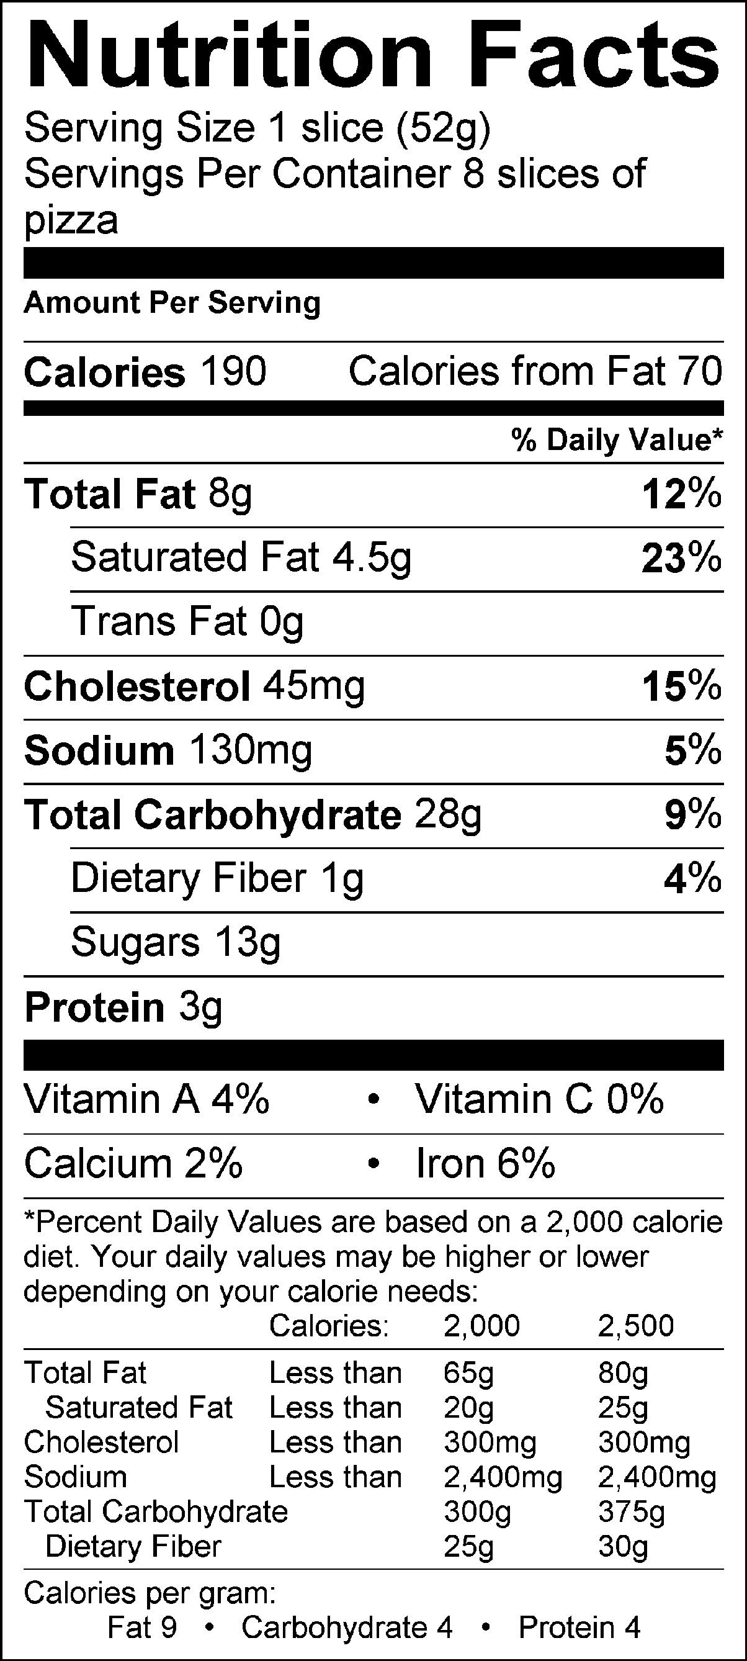 | 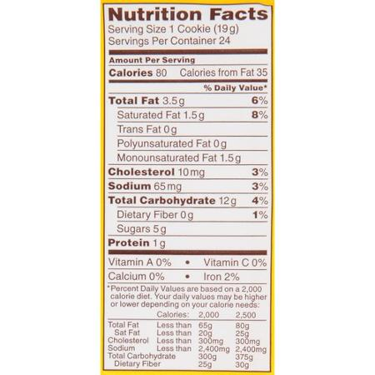  Note: This dough should make pizza cut into 8 slices, that means about 3 cookies per slice. The calories, etc., would triple from the listed amounts.

Fruit Pizza Cream Cheese Topping, scratch $1.79 | Cream Cheese Frosting, ready to spread can $1.38
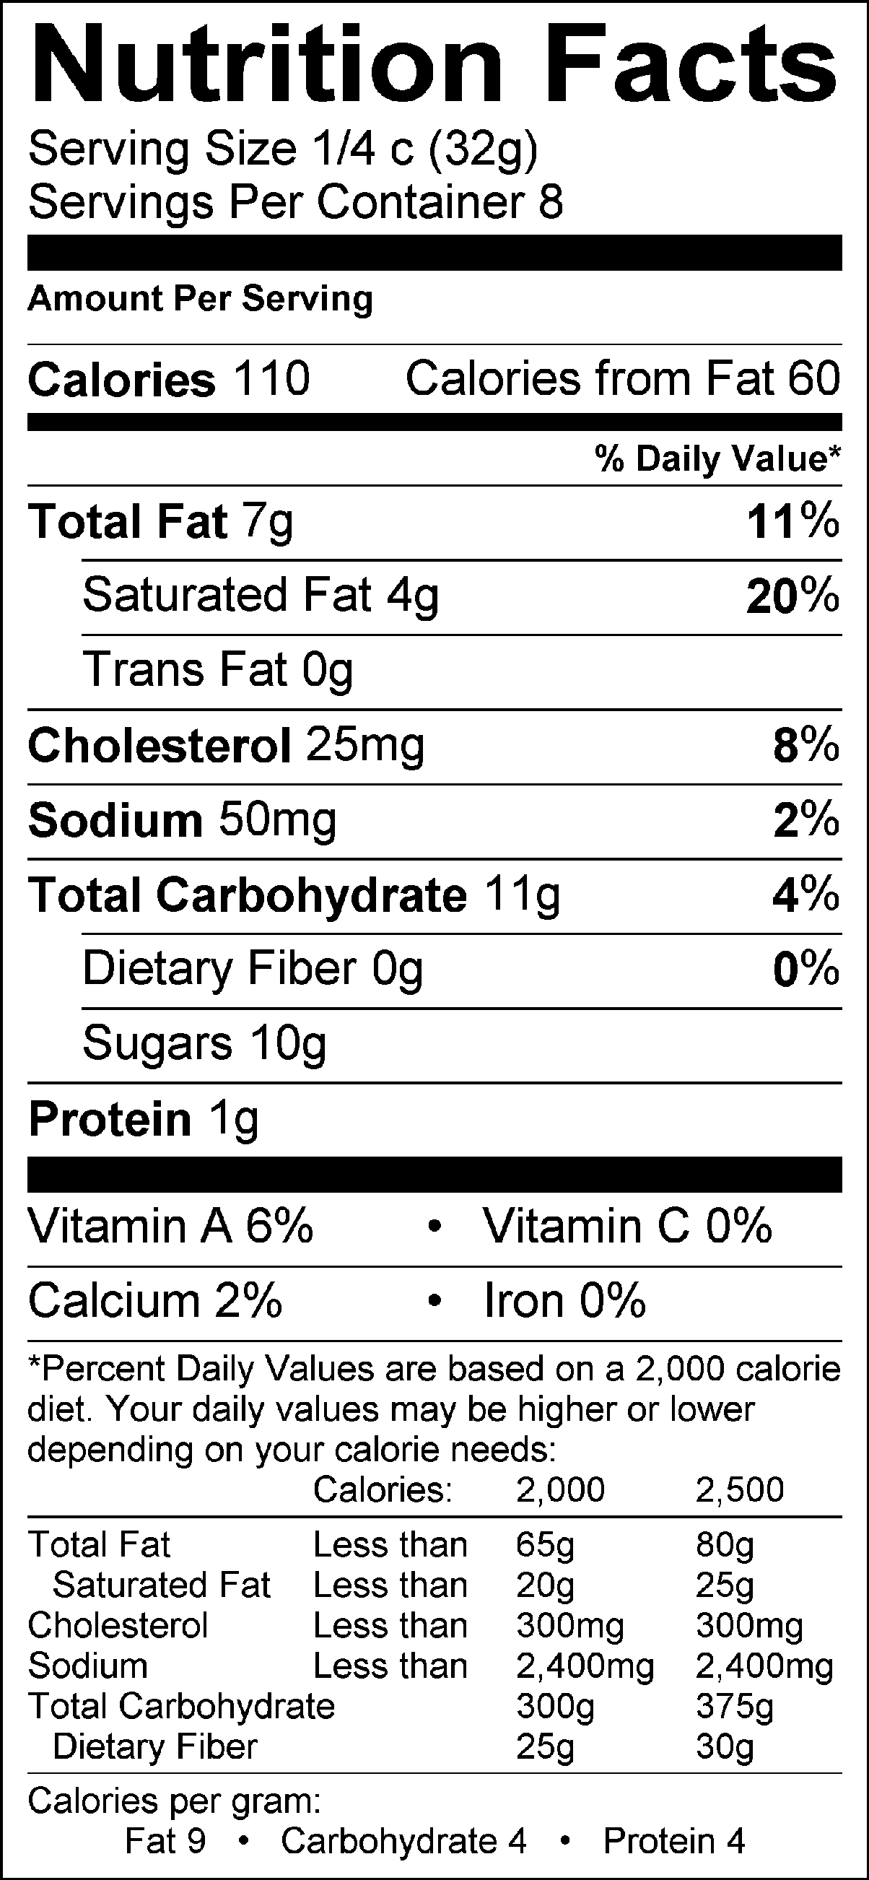 | Nutrition Facts  Serv Size 2 Tbsp (33g)  Servings Per Container  Amount Per Serving  Calories 140 Calories from Fat 50  % Daily Value*  Total Fat 5g 8%  Saturated Fat 2.5g 13%  Trans Fat 0g  Sodium 65mg 3%  Total Carbohydrate 22g 7%  Sugars 20g  Protein 0g  Not a significant source of cholesterol, dietary fiber, vitamin A, vitamin C, calcium and iron.  NOTE: The entire can would be used, about 2 cups, just like the scratch frosting. Per piece, the calories, etc., would double: figuring 1/4 c per piece is 4 TB of frosting.

Fresh Fruit Toppings: apple, banana, kiwi, grapes mandarin oranges, strawberries  $1.41 | Frozen Fruit Toppings: Strawberries, peaches, pineapple, and red seedless grapes  $2.20 | Canned Fruit Toppings: peaches, pears, grapes, pineapples, cherries, mandarin oranges  $1.26
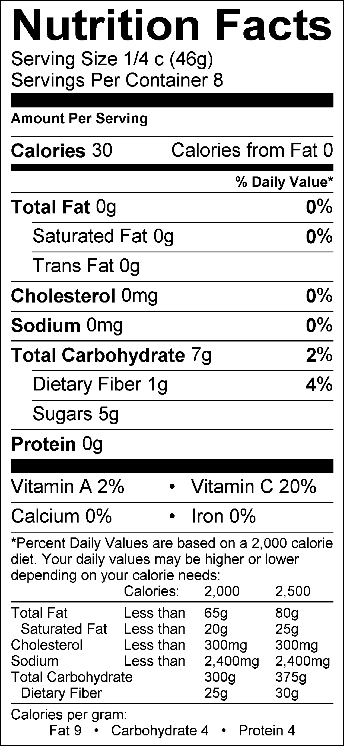 | 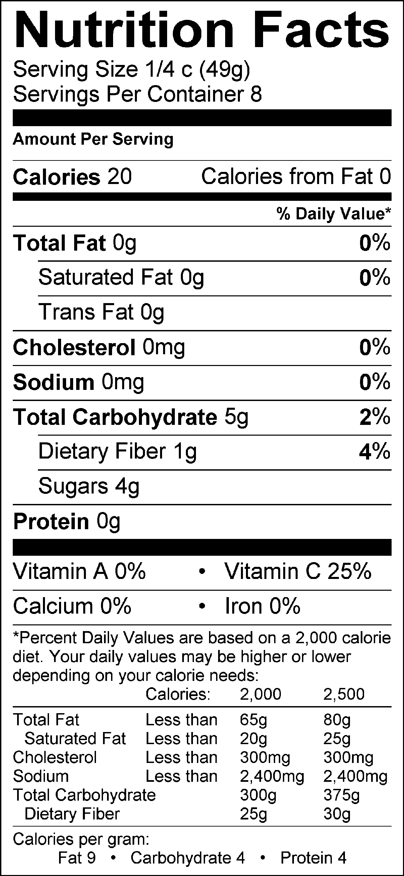 | 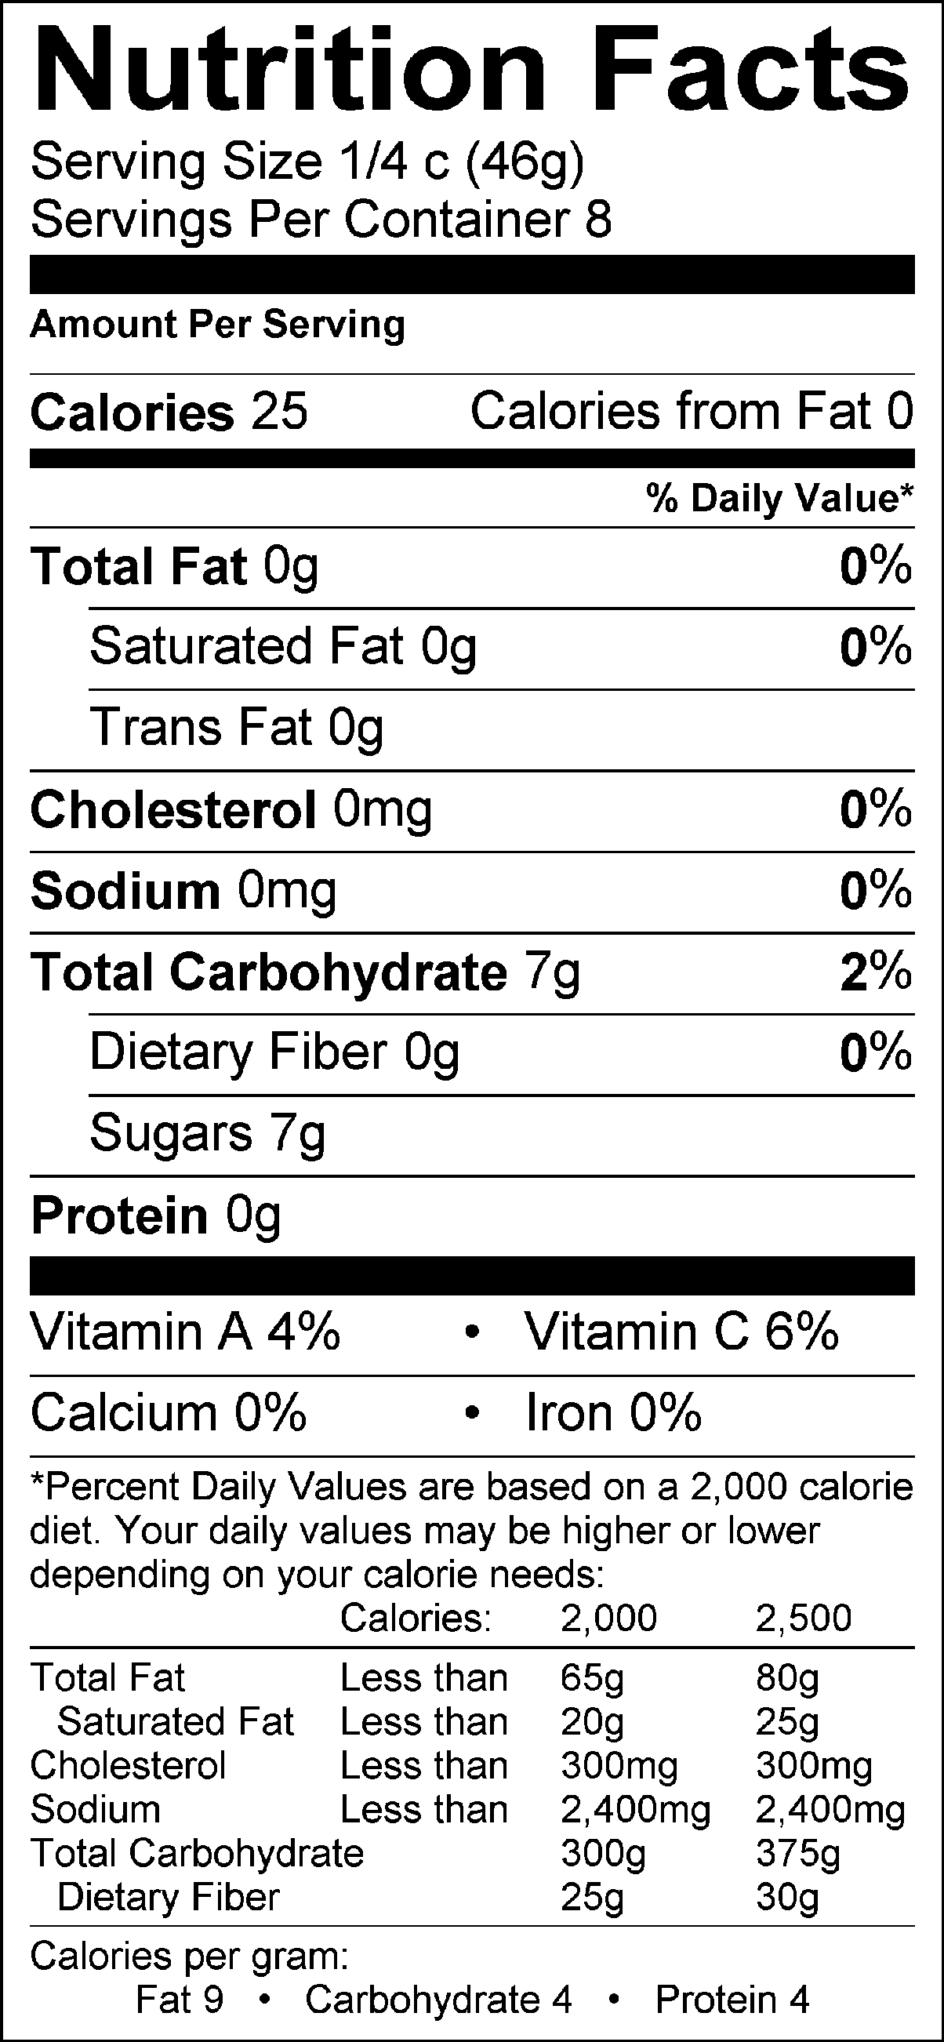

Note the differences in the heat-sensitive vitamin C!

Fruit Pizza

Sugar Cookie Dough: Topping: Fruit:
1 egg 4 oz. cream cheese 1/2 apple, chopped
1/4 c. butter 1/4 c. powdered sugar 1/2 banana, sliced
1/2 c. sugar 1 tsp. vanilla 1 kiwi, peeled, sliced
1/4 c. sour cream 1/4 c. sugar 1 bunch grapes, sliced
1/4 tsp. baking soda 1/4 c. whipping cream 1/4 c. mandarine oranges
1/8 tsp. salt 1-2 strawberries, sliced
1/4 tsp. vanilla
1 ¼ c. flour

1. Preheat the oven to 375°.
2. In the bowl attachment of the KitchenAid mixer, combine the sugar cookie dough ingredients, IN ORDER one by one, beating after each addition, using the flat paddle attachment. When the dough has been fully mixed, CHECK IT OFF WITH THE TEACHER before moving on.
3. Roll out the dough on a lightly floured countertop and then lift and place the dough onto a greased pizza pan or cookie sheet. Your group may choose to make one large fruit pizza, or small individual pizzas. If your group chooses to make individual fruit pizzas, be sure to bake them all at the same time on the same cookie sheet to make sure they get done in time.
4. Bake for 10 to 12 minutes, or until golden brown. Do not over-bake. Remove from the oven and allow to cool.
5. In a SMALL mixing bowl, beat the whipping cream with the handheld electric mixer until thick and stable. Set aside.
6. In a medium mixing bowl, beat cream cheese with the handheld electric mixer until smooth. Beat in powdered sugar, sugar and 1 tsp. vanilla.
7. Add whipped cream to the cream cheese mixture and beat until combined.
8. Spread the mixture onto the cooled cookie crust. Wash, peel and slice fruit to your liking. Arrange fruit on crust. Cut, serve and enjoy!

