Salsa Competition
Objective: Have students make an original salsa recipe and incorporate the following Strands and Standards listed below. Students will use proper knife skills, measure, write their recipes on 3x5 cards, and compare the vitamin and mineral nutritional value between fresh, frozen and canned, finding out what best fits their recipe.

Standard 1: Identify types, use and care of selected kitchen equipment. STEM (Technology): Knife skills
Standard 2: Identify abbreviations, food measurement terminology and demonstrate proper measuring techniques. STEM (Math) Measuring
Strand 5: Standard 1: Identify select vitamins, their food sources, functions and deficiencies in the body. STEM (Math/Science/Biology) Vitamins and Minerals comparison - Fresh, Canned, Frozen

1 Your salsa must include at least 1 fruit and 2 vegetables
2 Your salsa must be completed in 30 minutes
3 Your salsa must be edible by the majority of staff (watch the heat)
4 Your salsa must be aesthetically pleasing

Look up the difference between fresh, frozen and canned. Determine which has the best nutritional value, price value and taste.

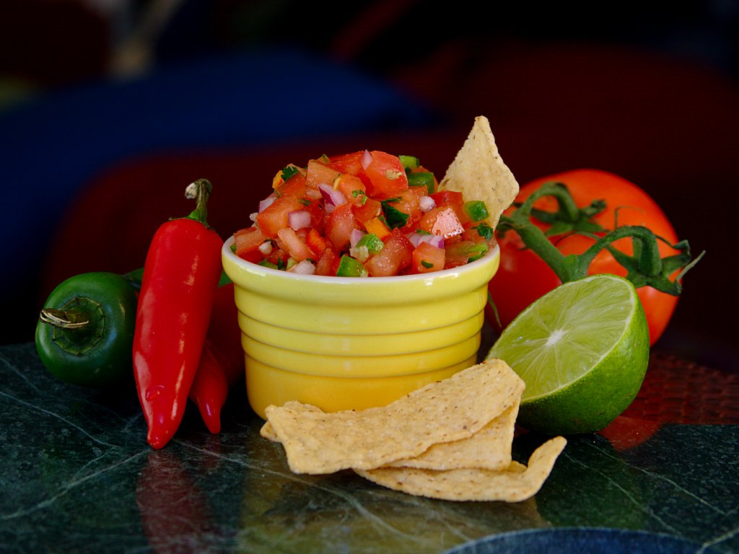

Salsa is a food that has a variety of ways to be made. Each table will be making a different type of Salsa and it will be judged. Here are the rules of the game. You must name your Salsa, for example: “Mango Brussel sprout delight” (remind me to skip this table!) Each question is worth 5 points

1 Your salsa must include at least 1 fruit and 2 vegetables
2 Your salsa must be completed in 30 minutes
3 Your salsa must be edible by the majority of staff (watch the heat)
4 Your salsa must be aesthetically pleasing

Name of Salsa, (remember you want to bottle and sell your salsa so name it well): _____________________________________________________________________________________
Team members making salsa: __________________________________________________________________________________________________________________________________________________________________________
1. Name the fruits used in the salsa: _______________________________________________________________________________________________________________________________________________________________________________________________________________________________________________________________

2. Name the properties that the fruits contain: _______________________________________________________________________________________________________________________________________________________________________________________________________________________________________________________________

3. Name all vegetables used in the salsa: _______________________________________________________________________________________________________________________________________________________________________________________________________________________________________________________________

4. Named the properties that the vegetables contain: _______________________________________________________________________________________________________________________________________________________________________________________________________________________________________________________________

