Snicker Doodle Recipes

|  |  |  |  |  |
| --- | --- | --- | --- | --- |
| |  | | --- | | **Jessica Kunzler <jessica.kunzler@nebo.edu>** | | Sep 30  https://mail.google.com/mail/u/0/images/cleardot.gif |  | **https://mail.google.com/mail/u/0/images/cleardot.gif**  **https://mail.google.com/mail/u/0/images/cleardot.gif** |
| |  | | --- | |  | | | |

<http://www.thepinningmama.com/soft-chewy-snickerdoodle-cookies/#_a5y_p=3579563>

On Wed, Sep 30, 2015 at 10:28 AM, Jessica Kunzler <[jessica.kunzler@nebo.edu](mailto:jessica.kunzler@nebo.edu)> wrote:

This is what I use.

**Brooke Dickert**

I just realized it didn't include the yield. It makes 48, so I have them cut it in half for the lab.

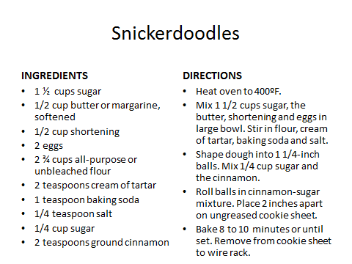

**Maribethclarke**

I would love your recipe when you get it. I have eight on my Pinterest Board (Maribeth Christensen Clarke) titled "Food-Desserts-Cookies" that include a Pumpkin Snickerdoodle, a Cheesecake Pumpkin Snickerdoodle, and a Gingersnap Snickerdoodle, along with 5 regular Snickerdoodle recipes.

Good luck,

Maribeth

This is the one we use and it works pretty great.  It will make about 16 cookies if they make them the correct size.  Laura Schiers

**Snickerdoodles**

**Cookie Dough: Topping:**

**1/4 c. shortening 1 1/2 c. flour 2 Tbsp. sugar**

**1/4 c. margarine 1 tsp. cream of tartar 2 tsp. cinnamon**

**3/4 c. sugar 1/2 tsp. baking soda**

**1 egg 1/8 tsp. salt**

1. **Preheat the oven to 400°.**
2. **In a medium sized mixing bowl, and using an electric mixer, cream together shortening, margarine and 3/4 c. sugar until light and fluffy.**
3. **Add egg to mixture, and beat with mixer again until smooth.**
4. **Remove electric mixer and add flour, cream of tartar, baking soda and salt to mixture and stir together with a wooden spoon until no dry ingredients are visible.**
5. **In a custard cup, combine cinnamon and sugar topping mixture and stir until well combined.**
6. **WITH CLEAN HANDS roll cookie dough into balls about the size of golf balls. Then, roll the dough balls in the cinnamon/sugar mixture until evenly coated.**
7. **Place the cookies on a greased cookie sheet, evenly spaced and then place the cookie sheet on the middle rack in the oven.**
8. **Bake at 400° for 8 to 10 minutes.**
9. **After they are done baking, let the cookies cool on the cookie sheet for 1 minute. Then, with a turner, move the cookies onto a cooling rack with a paper towel beneath them. Let the cookies cool for about 5 minutes then eat and enjoy!**

**Equipment You Will Need On Your Tray**

-3 Custard Cups

-1/4 c. dry measuring cup

-Measuring Spoons

-Spatula

-Cereal Spoon

**Daphne Stockdale**

**Snickerdoodles**

America’s Test Kitchen

1¾ c sugar  
1 T cinnamon  
2½ c flour  
2 t cream of tartar  
1 t baking soda  
½ t salt  
8 T butter, softened  
½ c veg. shortening  
2 lg eggs  
  
Heat oven to 375’. Combine ¼c sugar with cinnamon and a small bowl. Set aside. Whisk together flour, cream of tartar, baking soda and salt. Set aside. Beat butter, shortening and remaining 1½c sugar in a large bowl and add eggs. Blend well then add flour mixture. Using wet hands, roll 2T of dough into a ball and roll in cinn/sugar mixture. Bake for 10-12 minutes. These will spread so don't crowd the pan.

**Amy Carsten**

**​I've had really good luck with this recipe!  I have my students half it, then I check them off and they start working.  It makes a fair amount, but it depends entirely on how big the students make them.  I'd say about a dozen is a good estimate for an average size cookie.  Hope this helps!**

**Soft and Chewy Snickerdoodles (from Our Best Bites)**

**Ingredients**

**(You will make the half recipe)**

|  |  |
| --- | --- |
| CUT IN HALF | ORIGINAL |
|  | ¼ c. sugar (for cinnamon sugar) |
|  | 1 T. cinnamon |
|  | 1 ½ c. sugar |
|  | 2 ½ c. flour |
|  | 2 tsp. cream of tartar |
|  | 1 tsp. baking soda |
|  | ½ tsp. salt |
|  | 8 T. shortening |
|  | ½ c. butter (room temperature) |
|  | 2 eggs |

**Instructions**  
1. Preheat oven to 375 degrees. Grease cookie sheet with cooking spray.

2. Combine 2 T. sugar and cinnamon in shallow dish and set aside.

3. Whisk flour, cream of tartar, baking soda, and salt together in medium bowl.

4. Beat butter, shortening, and remaining ¾ cup sugar together until light and fluffy, 3-6 minutes.  Beat in egg until incorporated, scraping down bowl as needed.

5. Slowly add flour mixture until combined.  Give dough final stir to ensure that no flour pockets remain.

6. Working with 2 tablespoons of dough at a time, roll into balls.  Working in batches, roll dough balls in cinnamon sugar mixture to coat and set on prepared baking sheet spaced 2 inches apart.

7. Bake until edges of cookies are set and just barely beginning to brown, but centers are still soft and puffy, about 10-12 minutes.  The cookies should look raw between the cracks and seem underdone.  Let cookies cool on baking sheet for 10 minutes, then transfer to a wire rack and let cool to room temperature.

**Hudman, Janae**

This one works well even without chilling it.  It makes 24 cookies.

SNICKERDOODLES

2 3/4 cup flour

2 tsp cream of tartar

1 tsp soda

1/2 tsp salt

1 c soft shortening

1 ½  c sugar

2 egg

2 tbsp sugar

2 tsp cinnamon

Cream shortening, ¾ c sugar, and egg.  Beat until light and fluffy.  Mix in flour, cream of tartar, soda, and salt.  Chill until easy to handle.  Mix remaining sugar and cinnamon.  Form into walnut-size balls and roll in cinnamon mixture.  Bake at 400* for 8-10 minutes.

**bnewbury**

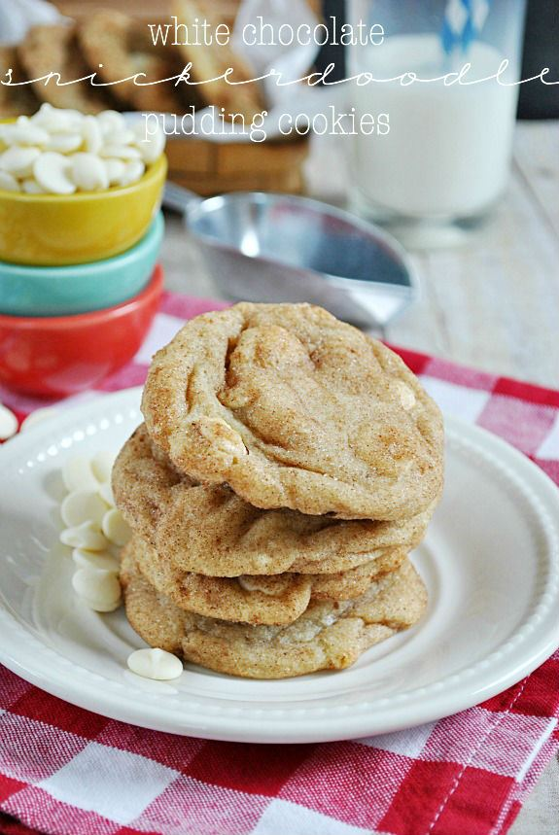White Chocolate Snicker doodle Pudding Cookies

Ingredients

* 1 cup butter, chilled
* 3/4 cup brown sugar
* 3/4 cup granulated sugar
* 1 tsp cinnamon
* 3.4 oz. package white chocolate instant pudding mix
* 2 large eggs
* 1 teaspoon vanilla extract
* 2 1/2 cups all-purpose flour
* 1 teaspoon baking soda
* 1 tbsp hot water
* 1/2 teaspoon salt
* 2 cups white chocolate chips
* 1/3 c. cinnamon-sugar for rolling (1/3 cup granulated sugar + 1 tsp cinnamon)

Instructions

1. Preheat oven to 350 degrees F.
2. Using a stand mixer, beat the butter until smooth.
3. Add the brown sugar and sugar. Beat for 1-2 minutes, until nearly creamy.
4. Add the eggs, one at a time and mixing in between additions.
5. Dissolve the baking soda in the tablespoon of water. Add both the baking soda and the vanilla to the mixer and mix well. Mix in the salt and cinnamon.
6. Add the flour and pudding mix, and mix until dough forms.
7. Mix in the white chocolate chips using a wooden spoon or spatula.
8. Scoop dough by heaping tablespoons and roll in the cinnamon sugar before placing onto a parchment lined or silicon lined baking sheet, 2 inches apart.
9. Bake for 10-12 minutes until edges are golden brown. Let cool on the baking sheet for a few minutes before removing to wire rack to cool completely.

Notes

Store in an airtight container once completely cooled. Makes approximately 48 cookies. *It's important that the butter is still a little cold and not room temperature, otherwise the cookies will spread too much. Leave it on the counter for about 30 minutes, and it will be perfect.

**Linda Woodfield**

Here is a recipe that works for us.  I separated out the cinnamon/sugar mixture to prevent mistakes, and put the preheat oven at the top of the instructions to prevent a different problem.  We only have 45 minutes to do these.  This recipe makes one crowded cookie sheet, or 1-1/2 better spaced cookies.

**Snicker Doodle Cookies**

**j02376161/4 c. shortening**

**1/4 c. margarine**

**3/4 c. sugar**

**1 egg**

**1 tsp. vanilla**

**1 ¼ cup flour**

**1 tsp. cream of tartar**

**½ tsp. baking soda**

**1/8 tsp. salt**

**2 Tbsp. sugar (Mix these in a separate little bowl—NOT in cookies!)**

**1 tsp. cinnamon**

**\*\*\*\*\*\*\*\*\*\*\*\*\*\*\*\*\*\*\*\*\*\*\*\*\*\*\*\*\*\*\*\*\*\*\*\*\*\*\*\*\*\*\*\*\*\*\*\*\*\*\*\*\*\*\*\*\*\*\*\*\*\*\***

1. **Preheat oven to 400 degrees.**
2. **Cream together shortening, margarine and sugar in large electric mixing bowl.**
3. **Add egg and beat well. Add vanilla and mix.**
4. **Sift dry ingredients together and gradually add to creamed mixture; mix well.**
5. **Roll into balls the size of a walnut. Then roll balls of dough in mixture of 2 T. sugar and 1 tsp. cinnamon.**
6. **Place two inches apart on an ungreased baking sheet. (May need to use two baking sheets.)**
7. **Bake at 400º for 8-10 minutes. DO NOT OVERBAKE!**

**Lori Henry**

SNICKERDOODLES

Ingredients

1 ½ cups sugar

½ cup butter or margarine, softened

½ cup shortening

2 eggs

2 ¾ cups Gold Medal® all-purpose or unbleached flour

2 teaspoons cream of tartar

1 teaspoon baking soda

¼ teaspoon salt

¼ cup sugar

2 teaspoons ground cinnamon

Directions

• 1 Heat oven to 400ºF.

• 2Mix 1 1/2 cups sugar, the butter, shortening and eggs in large bowl. Stir

in flour, cream of tartar, baking soda and salt.

• 3Shape dough into 1 1/4-inch balls. Mix 1/4 cup sugar and the cinnamon.

Roll balls in cinnamon-sugar mixture. Place 2 inches apart on

ungreased cookie sheet.

• 4Bake 8 to 10 minutes or until set. Remove from cookie sheet to wire rack.

**Stacie Durrance**

Makes about 2 doz.

SNICKERDOODLES

Yield: about 2 doz.

Ingredients:

¼ c. butter, softened

¼ c. shortening

¾ c. sugar

1 egg

1 1/3 c. and 1 Tbsp. flour

½ tsp. baking soda

1 tsp. cream tartar

1/8 tsp. salt

1 Tbsp. sugar

1 tsp. cinnamon

Directions:

1. Preheat oven to 400 degrees F .
2. In a large mixing bowl, cream together ¾ c. white sugar, shortening, butter, and egg.
3. In a medium mixing bowl, combine flour, cream of tartar, baking soda and salt. Mix well.
4. Add dry ingredients to liquid ingredients. Mix well.
5. Shape dough into 1 inch balls.
6. In a cereal bowl, combine 1 tbsp. sugar and 1 tsp. ground cinnamon.
7. Roll dough balls in the sugar/cinnamon mixture until coated and place 2 inches apart on ungreased cookie sheet.
8. Bake 8 to 10 minutes or until set, should not brown.

**mrs.baker**

I've found that margarine ruins cookies made in labs. They overspread. So I use butter or crisco for better success

**Ashley Langston**

I’m actually doing cookies today and that is one of my favorites! I think it includes the yield, but it makes about 2 1/2 dz.

**Snicker Doodles**

1 c. shortening

1 ½ c. sugar

2 eggs

2 tsp. cream of tarter

1 tsp. baking soda

1/4 tsp. salt

2 ¾ C. flour

3 Tbsp. cinnamon sugar

1. Preheat oven to 350* F.

2. Cream the shortening and sugar. Add the eggs and continue to cream the mixture.

3. In another bowl, combine the cream of tarter, baking soda, salt, and flour. Gradually add the dry mixture to the creamed mixture. Mix Well.

4. Roll the dough into one-inch balls. Pour the cinnamon sugar mixture in a small bowl. Roll each ball in the cinnamon/sugar mixture. Place the Balls of dough two inches apart on an ungreased cookie sheet.

5. Bake at 350* for 8 to 10 minutes. The cookies will puff up in the oven at first, and then they will flatten out.

6. Let cool on pan 1-2 minutes and then move to a cooling rack.

Yield: 3 dozen cookies.

**Raquelle Domenici**

**Snickerdoodle Cookies**

|  |  |  |
| --- | --- | --- |
| **Equipment needed:**  Kitchen Aid Mixer  Paddle attachment  Measuring spoons  Dry measuring cups  Metal spatula  Cookie sheet  Metal pancake turner | **Recipe:**  Preheat oven to 375˚.  ½ cup butter  1 cup sugar  1 egg  ½ teaspoon vanilla  ¼ teaspoon baking soda  ¼ teaspoon cream of tartar  1 ½ cups flour  In separate small bowl, mix:  2 Tablespoons sugar  1 teaspoon cinnamon  1. Cream together butter and sugar.  2. Add egg. Beat until fluffy.  3. Add soda, cream of tartar, and vanilla. Beat well  4. Add flour ½ cup at a time, beating well between each.  5. Roll dough into 1 to 1 ½ inch-sized balls. Roll in cinnamon-sugar mixture.  6. Place 2 inches apart on cookie sheets.  7. Bake about 8 minutes. Cookies will puff when baking and should appear cracked when done.  8. Remove cookies from cookie sheet with metal pancake turner and place flat on countertop to cool. | **Notes:**  This recipe is from Better Homes and Gardens New Cookbook |

**Jeanne Watson**

**SNICKERDOODLES**

3 ¾ c. flour Topping: 3 T. sugar

½ t. baking soda 1 t. cinnamon

½ t. cream of tartar

½ t. salt

1 c. margarine

2 c. sugar

2 eggs

¼ c. milk

1 t. vanilla

1. Preheat oven to 375’
2. Lightly coat cookie sheets with pan spray .
3. Combine flour, soda, cream of tartar and salt and set aside.
4. Beat margarine for 30 seconds; add sugar gradually and beat until fluffy (* * = to CREAM the shortening and sugar together)
5. Add eggs, milk and vanilla; beat well.
6. Gradually add dry ingredients beating until well combined.
7. Form dough into 1 inch balls; roll balls in the topping mixture.
8. Place balls 2 inches apart on a cookie sheet.
9. Bake at 375’ for about 8 minutes, until light golden in color.
10. YIELD: 5 ½ dozen

**Heidi Weight Weight**

This one has worked really well for me. It still might need some recipe size tweeking tweeking

**SNICKERDOODLES**

**(Make 1/2 recipe in lab.)**

Book: THS FOODS LAB RECIPES

Chapter: COOKIES

Cinnamon Sugar Cookie Preheat Oven to 400 F

Serves: 6 Yield: 2 ½-3 dozen

**Ingredients:**

1/2 cup vegetable shortening (1/4 cup)

1/2 cup butter (1/4 cup or 1/2 stick) OR margarine

1 ½ cups granulated sugar (3/4 cup)

2 eggs (1) **Note:** Eggs can be omitted if you are allergic and these still turn out great!

2 tsps cream of tartar (1 tsp.)

1 tsp baking soda (1/2 tsp.)

1/2 tsp salt (1/4 tsp.)

2 ¾ cups flour (1 cup +1/4 cup +2 Tbsp)

**Cinnamon/Sugar Mixture for Rolling: (NOTE: This is not added to dough!)**

2 Tbsps. granulated sugar (1 Tbsp.)

2 tsps. cinnamon (1 tsp.)

**Directions:**

1. Preheat oven to 400 degrees.
2. Cream shortening, butter, and sugar together. Don’t over beat or fats will become hot.
3. Add eggs to creamed mixture and beat. **Add remaining dry ingredients in the order listed**= important! (Note: If you are omitting the eggs, you may need to add a little water at a time to the dough to bring it to the right consistency if it is too dry.)
4. Roll dough into balls the size of walnuts. Use your cookie scoop for equal portions.
5. Roll in the mixture of sugar and cinnamon.
6. Place 2" apart on ungreased cookie sheet or cover cookie sheet with parchment paper.
7. Bake 10 minutes at 400 degrees. Cookies are done when they are crisp around the edges, soft in the center, and cracked on top. They will flatten after removing from the oven.

**Judy Mac**

**Laynee’s Snickerdoodles**

Makes 4 dozen

Prep time: 20 min.

Cook time: 10 min.

Total time : 60 mins

**Ingredients (Reduce by half for 2 dozen)**

______1 cup of butter

______1 1/2 cups of white sugar

______2 teaspoons vanilla extract

______2 eggs

______2 3/4 cups of all purpose flour

______2 teaspoons cream of tartar

______1 teaspoon baking soda

______1/4 teaspoon salt

A pinch of ground cinnamon

______3 Tablespoons of white sugar

______1 1/2 Tablespoons ground cinnamon

**Directions**

Preheat oven to 400 degrees

1. In a large bowl, cream together butter, sugar and vanilla.

Then add eggs and only cream till well blended. **Do not over mix.**

2. Blend together the flour, cream of tartar, soda, salt, and a pinch of cinnamon in a medium bowl. Gradually add to creamed ingredients.

3. Shape it into 1 1/2 in. balls.

4. In a cereal bowl, mix 3 T. of sugar and 1 1/2 T. ground cinnamon. Roll the balls of dough in the mixture.

5. Place 3 in. apart on ungreased baking sheets.

Bake for 8 to 10 min. or until set, but not too hard. Remove immediately from baking sheets.

**Mindy Johnson**

Snickerdoodles

• 1 cup flour

• ¾ tsp. baking powder

• 1/8 tsp. salt

• ¼ cup margarine

• ½ cup sugar

• 1 egg

• ¼ tsp. vanilla

IN A CEREAL BOWL:

• 2T. sugar

• ½ tsp cinnamon

Grease a cookie sheet. Stir together flour, baking powder, and salt in a separate mixing bowl.

Beat butter for 30 seconds in the kitchen aid, using the paddle attachment.

Add the sugar and cream till fluffy. Add egg, and vanilla; beat well.

Add dry ingredients to liquid mixture beating till well combined.

Form dough into 1-inch balls; roll balls into the sugar and cinnamon. Place ball on a cookie sheet.

Flatten slightly with bottom of a glass. Bake in a 400 oven 8 minutes or till light

**Cheryl Richards**

Snickerdoodles

Preheat oven to 350*

Mix together in a small bowl and set aside:

* 2 T. sugar
* 2 T. cinnamon

|  |  |  |
| --- | --- | --- |
| **Cream together:** | **½ recipe** | **Double recipe (2X)** |
| 1./2 C. shortening |  |  |
| ½ C. butter |  |  |
| 1 ½ C. sugar |  |  |
| 1 t. vanilla |  |  |
| 2 eggs |  |  |

|  |  |  |
| --- | --- | --- |
| **Sift together:** | **½ recipe** | **Double recipe (2X)** |
| 3 C. flour |  |  |
| ½ t. salt |  |  |
| ¾ t. soda |  |  |

Combine just until mixed.

Drop by teaspoon onto parchment lined cookie sheet, 1” apart

Roll each cookie into a ball and roll in cinnamon & sugar.

Bake for 10-12 minutes. Place cookies on a cooling rack