Thermometer Calibration
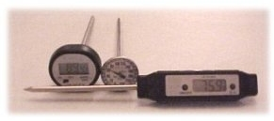A probe thermometer is used to take food temperatures and can either be a dial or digital thermometer. Both are reliable; however, digital thermometers can take temperatures of thin food while dial thermometers may have to be immersed up to 2 inches into the food to take a proper temperature.

When taking food temperatures, the probe should be placed into the thickest portion of the food. This placement is especially important for a whole turkey or large roast. Stir soups and sauces thoroughly before taking a temperature. Digital thermometers should be used when taking temperatures of thin food, like hamburgers or chicken breasts.
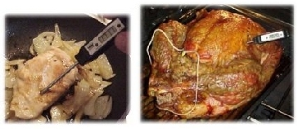

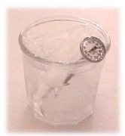How to you know a thermometer is accurate? The answer is to check it in ice water. Water freezes at 32º F.; therefore, a glass of ice water will be very close to 32ºF. By setting the thermometer in the ice water for a few minutes, you can find out if the thermometer is accurate if it correctly reads 32ºF.

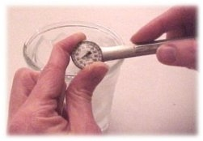What if my thermometer is not accurate? If it is a dial thermometer you can calibrate it. At the back portion of the dial, there should be a hex or square shaped nut. While the thermometer is still in the ice water, use a wrench to hold the nut secure and twist the dial portion until the temperature indicator is on 32ºF

