Soups
Advantages of Soups
1. Cheap
2. Make with leftovers
3. Appetizer or Main Dish
4. Contain meat, vegetables, milk, and grains
5. Easy
Disadvantages of Soups
1. Sometimes not filling
2. Hard to Eat

How Can Soup Be Served
- Appetizer???
- Main Entrée????
- Side Dish????
- Dessert????
- ANSWER__________________

As a Rule-One quart of soup will serve six an appetizer or three as an entrée

Soups Formula= ___Liquid__________+ _______Thickening Agent_________ (vegetables, grains, and meat)
What liquids could use ?
A. Broth
B. Milk
C. Tomato Soup
D. Water
2 Main Types of Soup
1. STOCK
Steps in Making Broth or Stock
1. Take worthy food scraps such as animal bones with some meat attached.
2. Create a MIREPOIX- the French name for a combination of onions, carrots, and celery this will add more flavor to the broth. sauces.

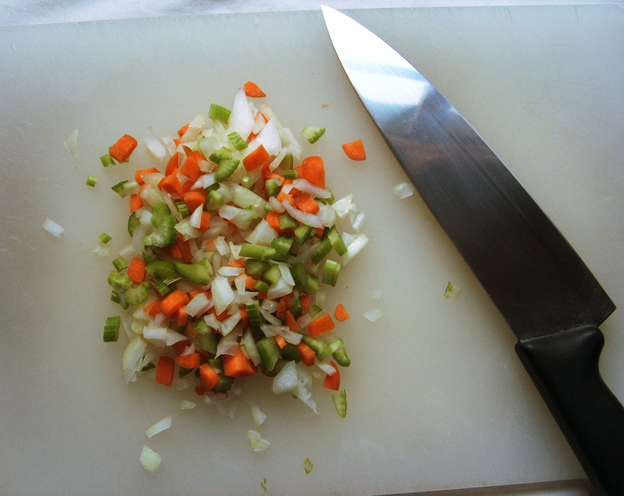
Mirepoix Formula
2 part onion
1 part carrot
1 part celery

3. Simmer for several hours

4. The broth is then strained and the ingredients discard.

What if you don’t have enough time to make your own broth?
1. Canned Broth
2. Bouillon cubes or granules and add water

How do you thicken a stock soup
1. Reduce the liquid
2. Add grain products like:
a. potatoes
b. barley
c. rice
d. pasta
e. Starchy grains absorb water and release starch as they cook or dissolve
Examples of Stock Soup
1. Beef Barley Soup
2. Chicken Noodle Soup
3. Egg Drop Soup
4. Minestrone

Method of Serving and Eating Soup
1. A soup spoon is smaller than a Tablespoon and larger than a teaspoon
2. A cup of soup is smaller than a bowl of soup.

3. Always place a soup plate under your soup bowl.
4. In using a soup spoon, dip the spoon away from you. Take the soup silently with the lips from the side of the spoon and not the tip.
5. Do not leave the spoon in soup dish. When not using it, place on the plate.
6. Never crumble crackers or toast in your soup and then stir it. It is permissible to put two or three pieces of cracker or toast on top of soup.

Tips for a great soup
- Saute chopped onions carrots, celery, and garlic This is Called ________________
- Add liquid and main ingredients
- Season and Simmer until all ingredients are tender

Garnish for Soups:
1. Croutons
2. Grated Cheese
3. Bits of Bacon
4. Crackers

Second Type of Soup:
- CREAM SOUP is made by creating a MOTHER SAUCE
Sauce | Liquid | Thickener | Color
Béchamel | Milk | White roux | White
Espagnole | Brown Stock | Brown roux | Brown
Tomato | Tomatoes | Tomato paste | Red
Hollandaise | Clarified Butter | Egg yolk | Yellow
Velouté | White Stock | Blond roux | Amber

a. Thicker soup
b. Created by using a Bechamel Sauce which is one of the 5 mother sauces.
c. Usually has the liquid milk in it
2. Bechamel Sauce sometimes refer to as a white sauce

So How do you Make a Bechamel Sauce??

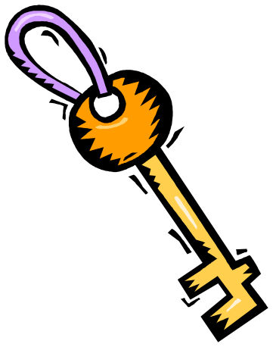The Key to Making a Bechamel Sauce is you must start with a ROUX

What is a Roux
- Thickening Agent
- Fat and Flour
- Create the roux first then add your liquid.

STEPS IN MAKING A BECHAMEL SAUCE

- Equal amounts of flour and fat
- The fat might be butter, margarine, or fat dripping
- Melt the fat over medium heat
- Stir in an equal amount of flour
- A paste will form
- Gradually stir in the liquid that you want to thicken
- Stirring constantly on medium heat until smooth and thick.

Sauce Type | Flour amount per one cup of liquid
Thin | 1T
Medium | 2T
Thick | 3T

NEVER-add flour directly to a hot liquid lumps will form.

Examples of Cream Soups
- Cream Potato
- Clam Chowder
- Cream of Broccoli

Other uses for a Bechamel Sauce
- Alfredo Sauce
- White Sauce

- Another way to thicken a soup is Cornstarch
- Cornstarch adds clear glossy finish
- Cornstarch has twice the thickening power of flour
- In a separate bowl add cornstarch and cold water mix well. Slowly pour and stir the mixture into the hot liquid.
- Simmer over medium heat until thickened stirring constantly to keep starch granules from separated
Sauce type | Cornstarch amount per one cup of liquid
Thin | 1 ½ tsp.
Medium | 1 T
Thick | 1 ½ tsp T

Storage of Soup
- Never store the soup in the soup pot in the refrigerator. (WHY)
  - The HOT soup pot will give off heat in the refrigerator and increase the temperature .
  - The increase temperature could contaminate other foods in the refrigerator
- Always store soup in shallow containers (WHY)
  - This will allow the soup to cool quicker and more evenly
  - The shallow container will not give off as much heat as a large pot.

