Name_________________________________________
Floor Plans and Furniture Arranging PPT Note Taking Guide
3 Basic Interior Zones
1.
2.
3.
Traffic or Circulation Path:

Good Family Circulation

Work Triangle:

Other Aspects of Good Work Circulation:

Service Entrance:

Guest Circulation:
Draw a line to connect the Important Room Relationships:

Bathroom
Kitchen
Mudroom
Garage
Kitchen
Living
Dining area
Kitchen
Garage
Dining
Bedroom
Outdoor living space

List any others you can think of:
What is a bird’s eye-view?
How to draw circulation patterns:

Types of drawings and description:
1.
2.
3.
4.
5.
6.
7.
What is scale?
What is the standard scale for floor plans? Chapter 20-21 pg 445-487
As you skim through the chapters, list the steps of design and summarize what takes place during these steps:
1.
2.
3. (pay attention to this one, you will need the info on page 454 for your own drawing)

4.
5.
6.
7.
8.
9.
10.
Chapter 10 Page 216
What are some important steps in planning where a house will be placed?
1.
2.
3.
What is a floor plan?
What is an elevation?
Using the steps you’ve read about, if you were a designer, what kind of housing and furniture would you think the following people have?
- A single woman, 20 years old, going to college, working at a coffee shop, likes to read and watch movies and would like a place to have a couple of friends over. She likes contemporary styles

- A single man, 28 year old, working as pilot, likes to watch sports and go the gym, would like a bachelor pad to have parties. He says he doesn’t care what it looks like as long as it’s cool.

- A married couple with no kids, and a dog, he works at a bank and she is a lawyer, they like to travel, collect art, and enjoy having other couples over for dinner.

- A married couple with 3 kids, he is a mechanic, she is a school teacher, their kids are involved in ballet and soccer, they like to go camping and often have a lot of friends and family over.

- A single mom with 2 teenagers, she is a realtor, one of her kids is into skateboarding, the other is into drama, they enjoy watching movies as a family and often have several of the kids friends over.

- A single dad with 2 teenagers, he is business owner, one of his kids is on the drill team, the other is on the basketball team, they enjoy going four wheeling and camping, they often have friends over.

- An older married couple, retired, no kids at home, she likes to bake and crochet, he likes to fish and work on projects in his garage, they often have their grandkids over to visit for the weekend.

- An older single man, is a truck driver, likes the outdoors and hunting. Doesn’t socialize much.

9. You come up with one of your own.

Assignment: Design a house and draw the floor plan. Use one of the scenario's listed above to help you decide what your house will need. You need to at least have a bedroom, bathroom, dining area, living area, and storage. Your first floor plan will use ¼ in scale. Your second floor plan will be identical to the first but drawn to ½ in scale
Draw and label at least 20 architectural symbols. Use page 222 in the book.
1. door 11. upper cabinet
2. window 12. lower cabinet
3. sink 13. light switch
4. fireplace 14. 110 outlet
5. stairs 15. 220 outlet
6. range 16. ceiling light
7. refrigerator 17.
8. tub 18.
9. shower 19.
10. toilet 20.

Page 378-382 in the book:
Color all the Living/social areas in YELLOW
Color all the Sleeping/Private areas in RED
Color all the Work/Service areas in BLUE

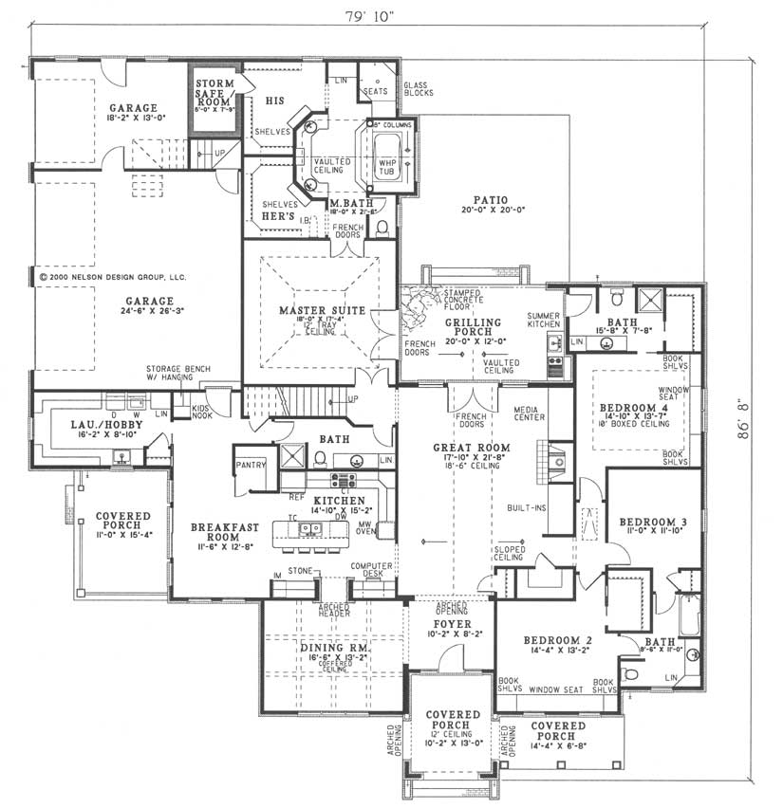
What do you like about this floor plan?

What don’t you like?
Furniture Arrangement PPT Note Taking Guide
Why is it important to understand the function of a room?
What are some mechanical or architectural functions to consider when placing furniture?
What are ways to create a feeling of balance in a room?

How can use furniture to emphasize a focal point?
List and draw examples of the different shapes used for seating arrangements?

What is the ideal distance for conversation areas?
What would be considered a secondary furniture grouping?
Why would you want durable and easily maintained furniture in social rooms?
What are the 3 types of space that should be considered for each person in a bedroom?
Assignment: Logon to Lazboy.com OR Polyvore.com and find the room planner option.
Start with only one room of the floor plan that you designed. Don’t use one of their templates because I’ll know it.
Using the principles and elements of design, and space planning we’ve talked about in class, create a furniture arrangement for your floor plan.
Use generic furniture and structural elements to create your room.
Show me so I can check it off before you turn off your computer.

