Name _____________________________________________ Living Zones & Circulation Path Evaluation
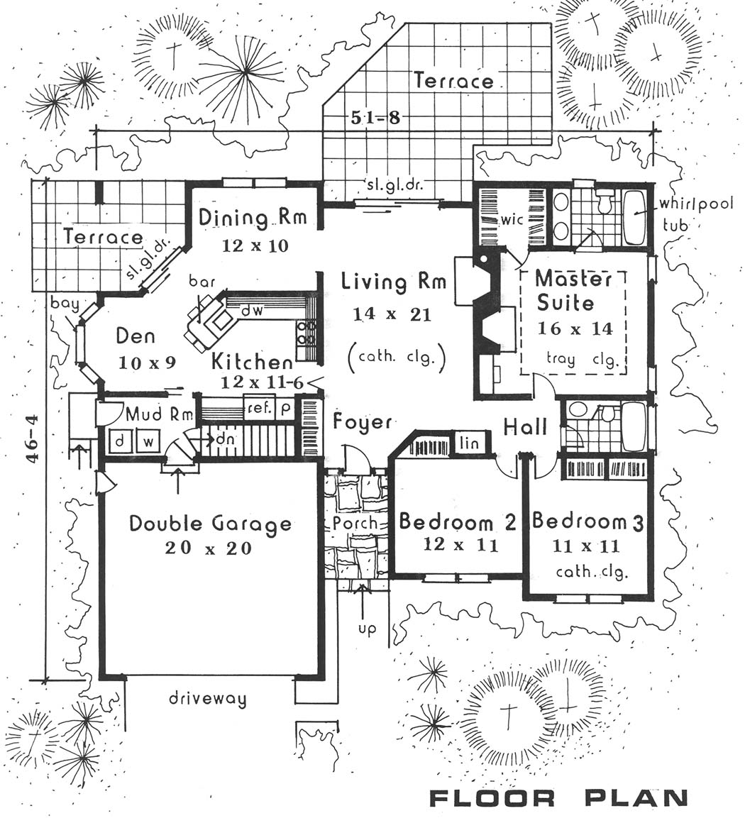

Color all the Living/social areas in YELLOW
Color all the Sleeping/Private areas in RED
Color all the Work/Service areas in BLUE

- Comment on the traffic pattern/circulation paths by listing 2 advantages of the traffic pattern:

- Comment on the traffic pattern/circulation paths by listing 1 disadvantage of a traffic pattern:

- Comment on 1 like of the house plan:

- Comment on 1 dislike of the house plan:

