Name **KEY** Date Period

Architecture & Furniture History

Test #1—Test A

* *Complete the items as directed. Remember to USE YOUR OWN PAPER AND DO NOT WRITE TEST!!!*

**MULTIPLE CHOICE**

*Choose the correct answer*

1. The Chippendale Style of furniture is identified by what?
   1. **The ball and claw foot.**
   2. Having the splat back.
   3. The slipper foot.
   4. The woven seats.
2. A furniture support that is the shape of a flattened ball is called what?
   1. Thimble Foot
   2. **Bun Foot**
   3. Flemish Foot
   4. Ball Foot
3. Among the prominent English furniture designer or master cabinet makers of the Late Georgian period, this designer was best known for heat, oval, wheel, and shield chair backs.
   1. Thomas Chippendale
   2. **George Hepplewhite**
   3. Thomas Sheraton
   4. The Adam’s Brothers
4. Furniture produced for the middle and high class market is linked to this time period.
   1. Regency
   2. **Victorian**
   3. Queen Anne
   4. Late Georgian
5. What influence is the Queen Anne period in England is known for in furniture designs?
   1. **Oriental**
   2. Italian
   3. Roman
   4. Egyptian
6. Which finish adds color to wood without covering the natural grain?
   1. Japanning
   2. **Stain**
   3. Varnish
   4. Paint
7. Pedestal based tables with curved legs and brass feet are typical of what time period?
   1. Queen Anne
   2. Hepplewhite
   3. **Duncan Phyfe**
   4. Shaker
8. The table with legs than be swung out to support the table is called a:
   1. **Gate-Leg Table**
   2. Chair Table
   3. Pedestal Table
   4. Drum Table
9. Which column style is the most decorative or ornate?
   1. Doric
   2. **Corinthian**
   3. Greek
   4. Ionic
10. How many sloping sides does a hip roof have?
    1. 1
    2. 2
    3. 3
    4. **4**
11. The chair back of Duncan Phyfe furniture is characterized by the use of the:
    1. **Lyre**
    2. Shield
    3. Ladder
    4. Splat
12. A porch with columns is a:
    1. Pilaster
    2. Palladian
    3. Pediment
    4. **Portico**
13. What is the frame work that holds the glass on a window?
    1. Wood
    2. Metal
    3. **Sash**
    4. Crank
14. Which of the following chairs was introduced by Thomas Chippendale?
    1. Lawson
    2. Tuxedo
    3. Windsor
    4. **Camel-Back**
15. The joint used for high quality furniture construction is:
    1. Dowel Joint
    2. Tongue & Grove
    3. Butt
    4. **Dovetail**
16. An early chair with horizontal slats in the back is called:
    1. **Ladder-Back**
    2. Queen Anne
    3. Victorian
    4. Windsor
17. Which of the following decorative motifs is used on Corinthian columns?
    1. Quoins
    2. Shell
    3. **Acanthus Leaf**
    4. Dentil
18. Which chair is characterized by using a shield back?
    1. Queen Anne
    2. Sheraton
    3. **Hepplewhite**
    4. Federal
19. What architectural feature demonstrates corners made of stone and adds decoration to the house?
    1. Gingerbread
    2. Half Timber
    3. Dentil
    4. **Quoins**
20. Which furniture was eclectic and used with elaborate and fanciful designs rather than simple designs:
    1. Duncan Phyfe
    2. Sheraton
    3. **Victorian**
    4. Chippendale
21. What window can be placed to the right or left of a door?
    1. **Sidelight**
    2. Sliding
    3. Skylight
    4. Double Hung
22. The chair back of Sheraton furniture is characterized by the use of the:
    1. **Square**
    2. Ladder
    3. Lyre
    4. Shield
23. Which styles of house generally have gingerbread decoration on them?
    1. Greek Revival
    2. Salt Box
    3. Federal
    4. **Victorian**
24. The top decoration on a highboy is called a:
    1. Lyre
    2. Pilaster
    3. **Pediment**
    4. Bracket
25. The Federal style can be distinguished by having:
    1. A Mansard Roof that is usually only a one level house.
    2. **Windows on the first floor that is taller than windows on the second floor.**
    3. Elaborate porticoes on all sides of the house with columns.
    4. Very few windows and mostly wall areas.
26. Which foot style is typically used on a Queen Anne chair:
    1. Bracket
    2. Bun
    3. Ball & Claw
    4. **Slipper**
27. The springs used in better quality upholstered furniture are:
    1. **Coil**
    2. Flat
    3. Box
    4. Set
28. One way to check of sufficient padding is an upholstered piece is to:
    1. Check the Label.
    2. Observe how puffy it is.
    3. Make sure it includes foam padding.
    4. **Sit on it to make sure you can’t feel the frame.**
29. Which type of column is illustrated by circular scrolls at the top?
    1. Corinthian
    2. Doric
    3. **Ionic**
    4. Roman

**PICTURE IDENTIFICATION**

*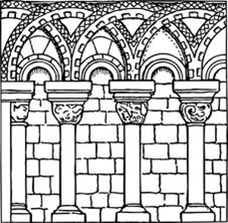Identify the correct architectural features.*

1. The following picture is an example of which of the following Architecture Features?
   1. Ball and Claw
   2. **Arcade**
   3. Arch
   4. Column
2. 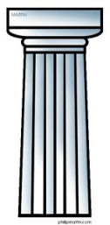What capital is pictured?
   1. Corinthian
   2. Column
   3. Ionic
   4. **Doric**



1. Which capital is pictured?
   1. **Corinthian**
   2. Column
   3. Ionic
   4. Doric

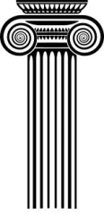

1. Which capital is pictured?
   1. Corinthian
   2. Column
   3. **Ionic**
   4. Doric

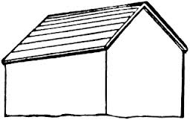

1. Which roof style is pictured?
   1. Gambrel
   2. **Gable**
   3. Hipped
   4. Flat

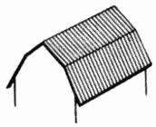

1. Which roof style is pictured?
   1. **Gambrel**
   2. Gable
   3. Hipped
   4. Flat
2. 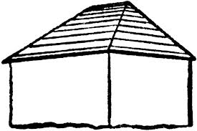Which roof style is pictured?
   1. Gambrel
   2. Gable
   3. **Hipped**
   4. Flat
3. 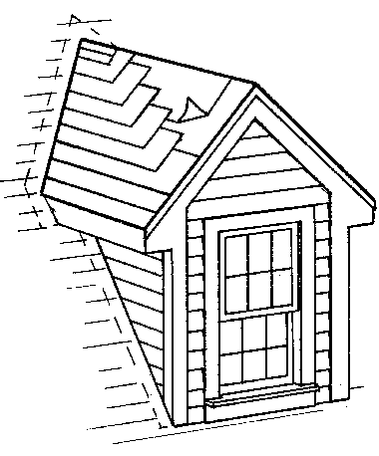The following picture is an example of what type of window?
   1. Casement
   2. Double Hung
   3. **Dormer**
   4. Palladian
4. 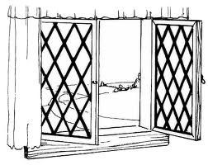The following picture is an example of what type of window?
   1. **Casement**
   2. Double Hung
   3. Dormer
   4. Palladian
5. The following picture is an example of what type of window?
   1. 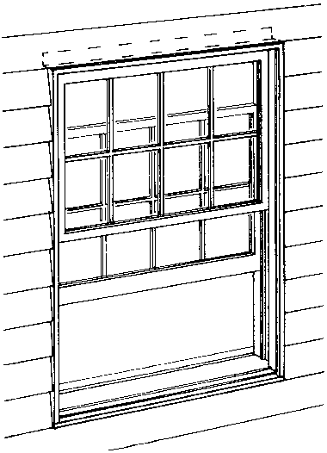Casement
   2. **Double Hung**
   3. Dormer
   4. Palladian

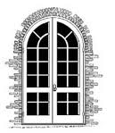

1. Which door is pictured?
   1. Single Door
   2. Exterior Door
   3. **French Door**
   4. Double Door

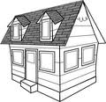

1. Which housing style is pictured?
   1. Salt Box
   2. Log Cabin
   3. Prairie
   4. **Cape Cod**
2. Which housing style is pictured?
   1. 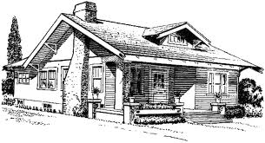Prairie
   2. **Craftsman/Bungalow**
   3. Greek Revival
   4. Cape Cod
3. The following picture is an example of what architectural feature?
   1. 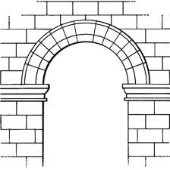Portico
   2. Pilaster
   3. Arcade
   4. **Arch**

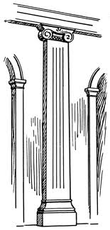

1. The following picture is an example of what architectural feature?
   1. Portico
   2. **Pilaster**
   3. Arcade
   4. Arch
2. The following is an example of what architectural feature?
   1. **Portico**
   2. 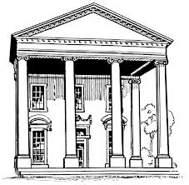Pilaster
   3. Arcade
   4. Arch

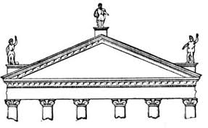

1. The following is an example of what architectural feature?
   1. Portico
   2. Greek Revival
   3. **Triangular Pediment**
   4. Archway
2. 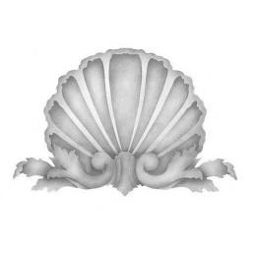This following is a motif commonly used during this time period?
   1. Early American
   2. **Queen Anne**
   3. Chippendale
   4. Victorian
3. The following chair is an example commonly seen during which time period?
   1. Early American
   2. Queen Anne
   3. **Chippendale**
   4. Victorian
4. 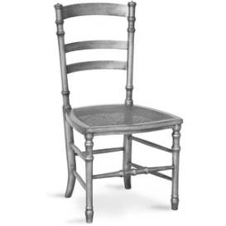The following chair is an example commonly seen during which time period?
   1. **Early American**
   2. Queen Anne
   3. Chippendale
   4. Victorian
5. 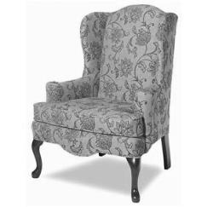The following chair is an example commonly seen during which time period?
   1. Early American
   2. **Queen Anne**
   3. Chippendale
   4. Victorian
6. The following chair is an example commonly seen during which time period?
   1. 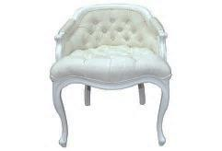Early American
   2. Queen Anne
   3. Chippendale
   4. **Victorian**
7. 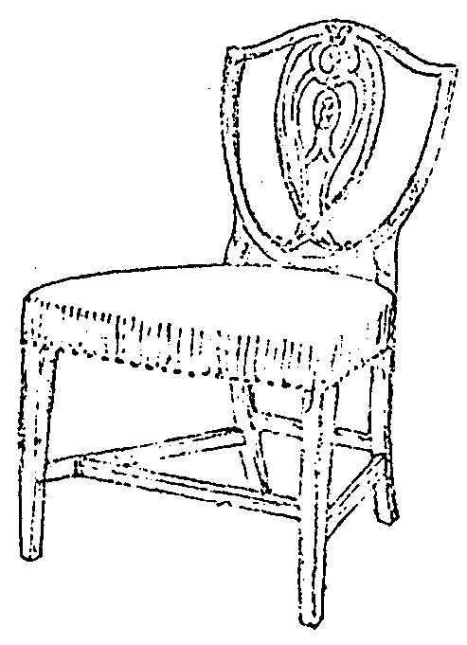The following chair is an example commonly seen during which time period?
   1. **Hepplewhite**
   2. Sheraton
   3. Duncan Phyfe
   4. Shaker
8. 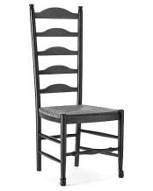The following chair is an example commonly seen during which time period?
   1. Hepplewhite
   2. Sheraton
   3. Duncan Phyfe
   4. **Shaker**
9. 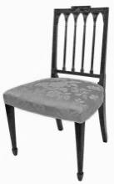The following chair is an example commonly seen during which time period?
   1. Hepplewhite
   2. **Sheraton**
   3. Duncan Phyfe
   4. Shaker
10. 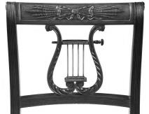This motif is commonly seen during which time period?
    1. Hepplewhite
    2. Sheraton
    3. **Duncan Phyfe**
    4. Shaker

**FURNITURE JOINT MATCHING**

*Match the following furniture joints with the correct picture.*

|  |  |
| --- | --- |
| 1. Butt **D** | a.  http://www.startwoodworking.com/sites/startwoodworking.com/files/uploads/taunton/images/1-mortise-tenon%281%29.jpg |
| 1. Corner **E** | b.  https://encrypted-tbn0.gstatic.com/images?q=tbn:ANd9GcR_AFfADNFaS5N3o4Lfub0INL1a484JHkEu5zjXx1bgw2sgtvT81Q |
| 1. Dove-Tail **B** | c.  http://www.startwoodworking.com/sites/startwoodworking.com/files/uploads/taunton/images/Tongue%20Groove.JPG |
| 1. Dowel **F** | https://dtatist.wikispaces.com/file/view/butt_joint.gif/156408089/butt_joint.gifd. |
| 1. Mortis & Tenon **A** | e.  http://o.quizlet.com/evYLCzxL6MIQJ4wfnXdp2Q_m.jpg |
| 1. Tongue & Grove **C** | f.  http://upload.wikimedia.org/wikipedia/commons/e/e9/Woodworking-joint-butt-dowel.gif |