CREATE A BULLETIN BOARD

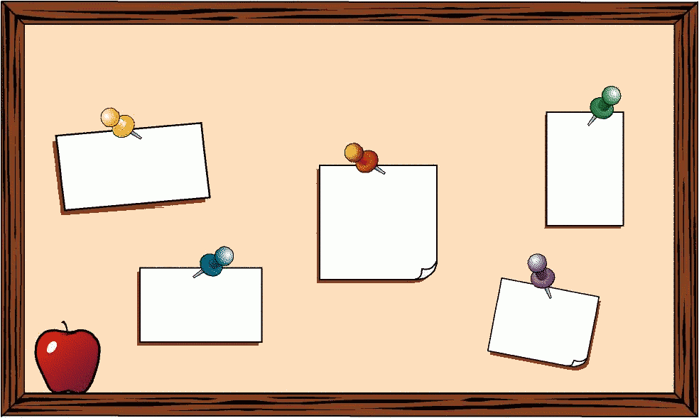
Use you creativity to design a bulletin board that teaches concepts we have learned in class. Please take a handout from the folder and follow the instructions.

Bulletin Board

Objective: Using classroom instruction materials, design a bulletin board on a subject related to something we have discussed in class, or an idea from your teacher.
Instructions
- Select a topic.
- Get the topic approved by your teacher.
- Use textbooks, handouts, and other classroom materials to find information about your topic.
- Come up with a concept for assembling your information. Be creative. How can you display your information in an appealing manner?
- Draw your bulletin board on the paper provided.
- Answer the three questions on included worksheet.
- Hand in drawn concept and worksheet to instructor.

Name______________________________
Bulletin Board Concept
Questionnaire
Topic:
- What facts and information will you include in your bulletin board? How does this information relate to consumerism?

- How can the information provided on your bulletin board benefit other students?

- What did you learn from completing this activity?

Name__________________________
Draw Your Design Here

