DINING OUT Bucket List
When you eat soup you should scoop away from you and tip it into your mouth. Don’t blow on it to cool it down. Instead scoop from the outer edges. | If you want ice cream with your pie, you will need to tell the server you would like your dessert  “a la mode.” | The person who clears the table is called the “bus boy” or in a fancy restaurant is called a table “attendant.”
A valet will park your car. Plan to tip them $5.00. | Your main dish is called an entrée. | Your waiter/waitress will take your order.
A coat check will hang your coat. Remember to tip them a couple of dollars for it. | The person that greets you and gets you to your seat is called a host/hostess. | Each consecutive part of a meal is called a course. A typical fancy meal will have 5-7 courses.
Gratuity is another name for tip. A tip is given to those who serve you in a restaurant and should be 15% of your bill. | Appetizers come at the beginning of a meal and are served to prepare the stomach for the main dish that is why they are salty. | If something is wrong with your food, politely let your waiter/waitress know. After all, they are not the ones that  made it.
When you want to eat something that isn’t necessarily a part of the meal you ordered, you will need to order it separately or as the French say,  “a la carte.” | The person who is paying for the date should order first so that their date will know the price range to order in. | In the past the boy has been the one that places the order; but now it is the person who is paying for the meal, be it the boy or the girl.
If you ask for your steak to be:  Rare – it will be red in side.  Med. Rare – it will be pink  Med. Well – it will be barely  pink  Well – it will be cooked clean  through | If you need to leave for a few minutes during a dinner to go to the bathroom or answer your cell phone, put your napkin on your chair. | When you are ready to leave at the end of a meal, your napkin should be placed on the left side of your plate.
Gum chewing can be quite rude when it comes to a fancy restaurant. Make sure to get rid of it before you get there or ask the waiter/waitress for a paper napkin to deposit it in. | Boys heads up...  Make sure you stand each time a girl gets up and excuses herself from the table and then again when she returns. | Don’t want hot beverages such as tea/coffee?  No problem! Keeping your cup turned upside down on the saucer lets your server know that you are not interested in having either of them

In the Know About

Dining Out - Questions

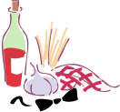
1. Match the following words to the proper term:
_____a la carte a. greeter/seater
_____valet b. successive parts of a meal
_____host/hostess c. tip
_____entrée d. hangs coats
_____waiter/waitress e. main dish
_____gratuity f. parks car
_____course g. each item priced separately
_____coat check h. clears table
_____attendant i. order taker/server
_____al a mode j. served with ice cream

2. How do you know what to order with your date?_________________________________________
3. Who should do the ordering?________________________________________________________
4. True/False An appetizer comes at the end of the meal.
5. True/False An appetizer is served to prepare the stomach for the main dish.
6. The waiter/waitress pours water on the _______________, serves on the ________________ and
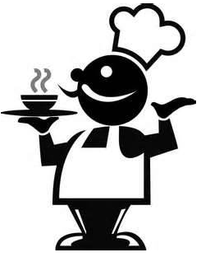
then picks up dirty dishes on the _____________.
7. How do you properly eat soup? ______________________________________________________
8. What should you do if there is something wrong with your food? ___________________________
9. Describe how the following steaks would look when served.
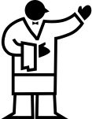
a. rare - ______________________________________________________
b. medium rare - _______________________________________________
c. medium well - _______________________________________________
d. well - ______________________________________________________

10. Where do you put your napkin if you must leave for a few minutes? ________________________ _________________________________________________________________________________
11. Where do you put the napkin when you leave at the end of the meal? _______________________
_________________________________________________________________________________
12. Does the boy need to rise when the girl excuses herself? _________________________________
13. What should you do with your gum? _________________________________________________
14. What should you do if you spill, break or drop something? _______________________________
________________________________________________________________________________
15. What should you do with your cup if you do not want a hot beverage (tea/coffee)? ____________ _________________________________________________________________________________
************************

