Value Ranking

What do you value most in life? There are 21 values listed below. Place an “X” in the column across from the value that best represents you.

Value | Extremely Important | Important | Not Important
Wisdom: having mature understanding, insight, good sense and good judgement
Wealth: having many possessions and plenty of money for the things you want
Trustworthiness: ability to be honest, straightforward and caring
Skill: being able to use your knowledge effectively, being good at doing something important to you
Religious Faith: having a religious belief
Recognition: being important, well-liked and accepted
Power: position of control, authority or influence
Pleasure: satisfaction, gratification, fun, joy
Physical appearance: concern for your attractiveness, being neat, well-groomed, clean
Morality: believing and keeping ethical standards, integrity
Loyalty: maintaining allegiance to a person, group or institution
Love: caring, compassion, devotion
Knowledge: seeking truth, information, or principles for satisfaction or curiosity
Justice: treating others fairly or impartially, conforming to truth, fact, or reason
Honesty: being frank and genuine with everyone
Health: the condition of being sound in body and mind
Creativity: the creating of new ideas and designs, being innovative
Job: your life-time work
Family: your present family and your future family
Education: school, college
Achievement: accomplishment, results brought about by resolve, persistence, or endeavour

My top 5 values are:
Directions: Click on the drawing below and choose “edit”. Type in your top 5 values in each of the puzzle pieces.
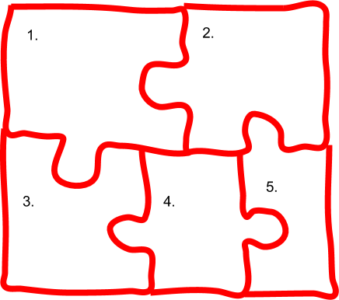

Identifying my values helps solve the puzzle pieces of the teen years.

