Table Setting to Impress
***The “HOW” when it comes to setting a fancy table***

Directions: Using the picture below and with the given tablecloth, dinner-, flat- and glass-ware, create a formal place setting. Make a place card (name tag) with the names and period of your group on it (make sure your names are all visible), and take a picture with the camera provided.

Then sketch the different items on the provided piece of paper and draw lines from the place setting items to their appropriate names. Glue the “formal place setting” paper in your journal.
Formal
Place setting
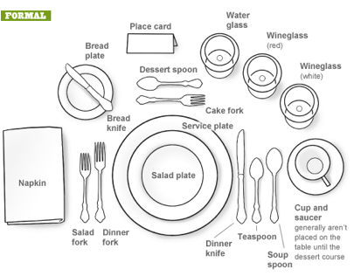
/Punch

