Utahn's heated jacket becomes 2nd most-funded Kickstarter clothing project
https://ksl.com/?sid=37768269

PROVO — Kickstarter's charts of most-funded projects now include a line of heated jackets from Provo.
The Ravean campaign raised $1,330,293, making it the second most-funded apparel project in the history of the crowdfunding site, according to Kickstarter. The heated down jackets, vest and sweatshirts are lightweight and have the ability to charge phones.
"We're from Utah, so we like the outdoors and like skiing, hiking, rock climbing and just being outdoors," co-founder Bryce Fisher said in October. "Outdoor apparel is something we're interested in. It seemed like a great product for us to pursue."
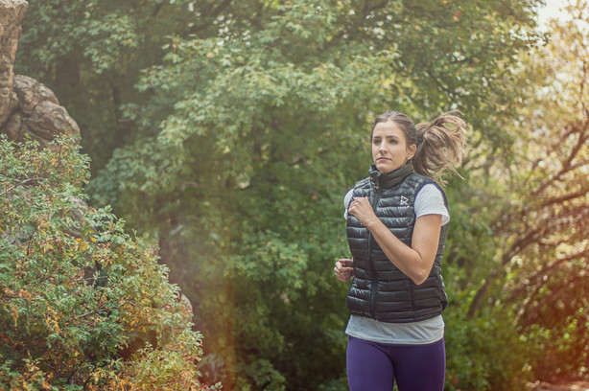Photo: Courtesy of Ravean
While the Kickstarter campaign ended on Nov. 30, Ravean jackets can still be pre-ordered through Indiegogo. Prices start at $129.
Previously, Fisher said Ravean planned to continue to expand its line of jackets to include more colors and new coat concepts. The team aims to not only make itself into a strong e-commerce company, but also get into big-box retailers.
To date, the No. 1 most funded apparel project on Kickstarter is "The World's Best Travel Jacket" from Chicago-based Baubax, according to the crowdfunding website. That campaign raised $9,192,055 before it ended in September.

https://www.ravean.com/
Do a search on Youtube for Ravean and you will find numerous videos that review the product.

