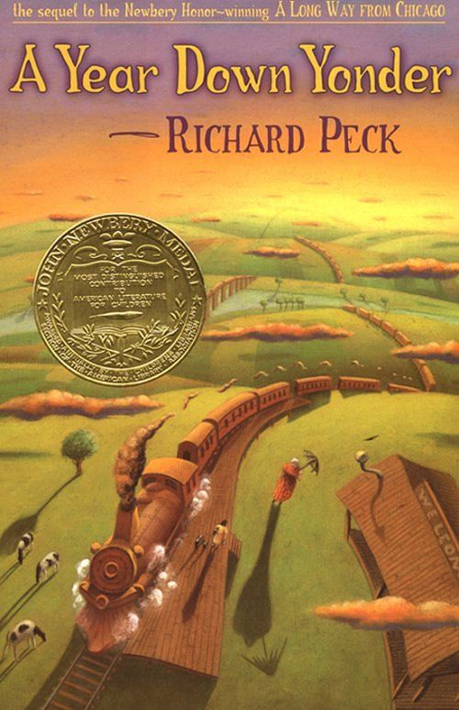
Name _________________________
Date _______________ Period _____
Analysis Questions
- What does the rural setting contribute to this story? Why is it important?
__________________________________________________________________________________________________________________________________________________________________________________________________________________________________________________________________________

- How has living in a small town affected Grandma’s personality and life?
___________________________________________________________________________________________________________________________________________________________________________________________________________________________________________________________________________________

- How does living in this small town with Grandma affect Mary Alice’s life?
___________________________________________________________________________________________________________________________________________________________________________________________________________________________________________________________________________________

- How does a person’s environment influence who or what that person becomes?
___________________________________________________________________________________________________________________________________________________________________________________________________________________________________________________________________________________

