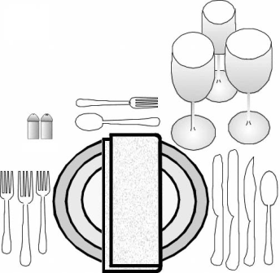
TABLE SETTING AND ETIQUETTE
STUDY GUIDE

Name:___KEY________________________ Period:_____

- Setting the table influences
  - Appearance of the food served.
  - Sets the tone/feeling of the meal.
  - Makes people feel important.

- Three Components of a Place Setting
  - Dinnerware
  - Flatware
  - Glassware

- Cover
  - Arrangement of a place setting for one person.
  - Allow 20-24” for each cover with the dinner plate in the middle.

- Proper Dinnerware Placement
  - Dinner Plate: 1” from the table edge
  - Bread/Butter Plate: Top left and above the salad plate
  - Salad Plate: Lower left and above the napkin
  - Soup Bowl: On the dinner plate or a separate soup plate

- Types of Flatware
  - Soup spoon – larger than teaspoon
  - Salad/dessert fork – smaller than a dinner fork
  - Butter knife – shape and size smaller than dinner knife

- Proper Flatware Placement
  - How many inches from the table’s edge? 1 to 1 ½”
  - Forks: left of the plate; dessert fork placed above the center of plate
  - Knives and Spoons: right of plate; dessert spoon above center of plate
  - Arrange in order of what? Use; starting at the outside and working toward the center.
  - Forks with tines where? Tine up
  - Knives with sharp cutting edge towards where? Towards the plate
  - Spoons with the bowls (of the spoon) where? Bowls up
  - Butter knife placed where? On the bread/butter plate

- Proper Glassware Placement
  - Water goblet: Tip of the knife blade.
  - Other beverage glasses: right of goblet, slightly forward & diagonal
  - Cup and saucer: lower right

- Placement of Napkin
  - Three places:
    - Left of the forks
    - Center on the dinner plate
    - In the water goblet
  - When napkin is removed, it should never what? Disturb the flatware

- Common Rules of Etiquette
  - Sitting down: From the left side of your chair.
  - Passing food: to the right.
  - Napkin:
    - Place on lap before starting to eat
    - Cover your mouth and nose if you must cough or sneeze.
    - Leave on your chair if leaving the table and returning during a meal.
    - Leave to the left of the plate when finished with the meal
  - When eating with a small group: wait until everyone is served before eating
  - Follow the actions of whom? Host/Hostess
  - Avoid talking with what in your mouth? Food
  - Chew with your mouth what? Closed
  - Cut food: Into bite-sized pieces; as you eat, not all at once.
  - How should you sit at the table? Sit up straight
  - Avoid leaning on what at the table? Elbows
  - When finished with soup: Place spoon on soup plate
  - Eating a roll/bread:
    - Break one piece off at a time, butter and eat.
    - Place butter on your own plate before buttering your bread/roll
  - Tipping Etiquette: For good service: 15-20% of the total bill
  - Where to tip? Restaurants and beauty salons
  - Cell Phone Etiquette:
    - Turn your cell phone to vibrate or off.
    - Avoid checking your phone.
    - If it is an emergency, excuse yourself from the table
    - Keep your voice down when talking on a cell phone

