A to Z poem
Instructions:
- You will be writing poem, called an A to Z poem. After you finish the A to Z poem, you need to find and publish one of your poems that you’ve written so far: Narrative Poem, Catalog poem, Petrarchan sonnet, or this A to Z poem. Turn in the website and cover letter to your teacher as well as which poem you chose to submit. You will be turning in the A to Z poem as well, unless that’s the poem you wanted to use, don’t need to turn in twice. If you received comments on another poem and fixed the poem then, the newer version would be the one you should submit.
- Create an A to Z poem.
- An A to Z poem is a poem listing the entire alphabet to describe something. You need to write about one of the following:
- Your favorite weather, this class overall (be nice please), favorite holiday, or best friend.
- 26 lines
- The first word in every line should be that letter in the alphabet. We will eXcept exceptions for X as long as the next letter is X.
- Include a picture to help us visualize, drawn or from the computer.
Here’s an example:
A to Z
Rain storm
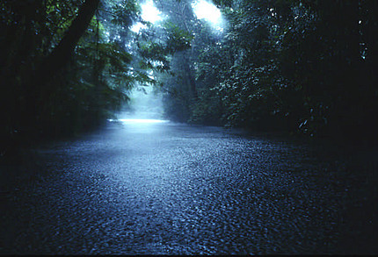
Around the time the clouds roll in
Bustling starts to sound.
Children run inside from the storm and
Drivers like to pull over.
Evening seems to fall over the sky while
Forming drops pool on the
Ground, which makes it wet.
Hard beating thuds across my roof
I would run into the storm
Just as soon as my mother would let me.
Lost beads of the rain find their way to
Make everything damp.
Nine birds huddle in a tree
Overcome by the cold.
Pieces of leaves fall from the weight of the
Quick water to the earth below.
Round drops slide down the window while my
Slit eyes are pressed hoping that
Time will stop and the
Uneven storm will never end.
Violins are
X-actly what you’d listen to if the rain were
Yet to fall making a thumping
zzzzzzzzzzzzz sound.

Your turn, create an A to Z Poem below and follow the rules above.

