Student Page
Standard II Name ___________________
Objective 2. d Date ____________________
Period ___________________

Title: Models of Earth

Introduction: We make models of almost everything. Can you think of some models that you have seen? It is very difficult to make models of things that we cannot see but can learn about by using tools. In this activity you will see some of the early models of the inside of the Earth along with a current model.

Prediction/Hypothesis: If you asked a first grader what the inside of the earth looked like how do you think they would describe it?

Procedures:
1. Use the toothpicks or skewers and gently probe the “Earth” your teacher has provided. Draw a picture of what you think it looks like inside. Remove the clay and draw what was really there.

What I think is inside: What was inside:

2. Read the information below about three models of Earth that have been proposed in the past and write down evidence that may show that was a correct model and evidence that the model may be wrong. Then in small groups talk about your answers and combine your answers to make a really good answer.

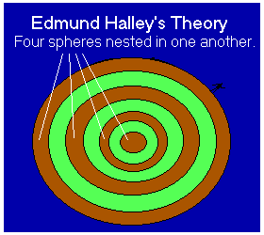
In 1692, Halley proposed that the Earth was hollow and within it was a second sphere. To account for all the variations in the magnetic field, Halley finally proposed that the Earth was composed of some four spheres, each nestled inside another.

1. What evidence is there that this is a good model?

2. What evidence is there that this is NOT a good model?
In 1846 the discovery of an extinct wooly mammoth frozen in ice in Siberia was used by Marshall Gardner as evidence of a hollow earth. Gardner subscribed to the single-sun-inside-the-earth theory and suggested that the mammoth was so well-preserved because it had died recently. Gardner thought that mammoths and other extinct creatures wandered freely in the interior of the earth. This one had wandered outside by using the hole at the North Pole, then was frozen and carried to Siberia on an ice flow.

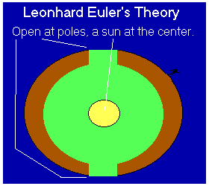
- What evidence is there that this is a good model?

- What evidence is there that this is NOT a good model?

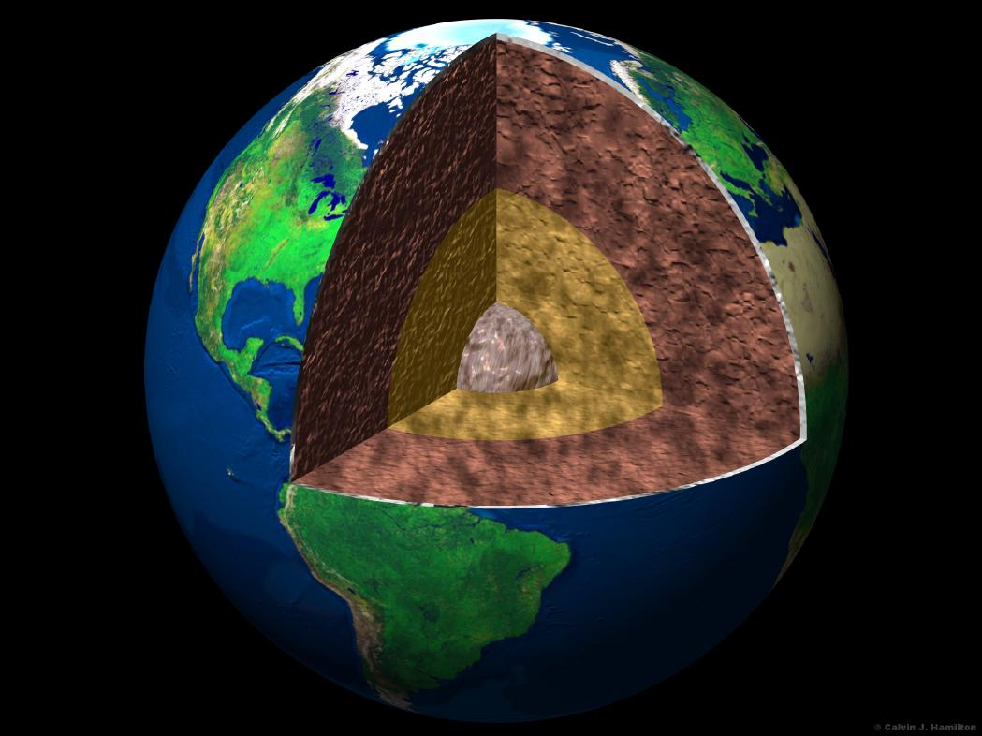
- What evidence is there that this is a good model?

- What evidence is there that this is NOT a good model?

Conclusion: What are two things you learned?

