Student Sheet Name
Date
Period

Osmosis in cells

Before You Read: Use your textbook, notes, or prior knowledge to define the words below.

Diffusion:

Osmosis:

Directions: Use the information above to complete the problems below.

1-6 Draw arrows in each of the pictures below to show whether water will move in or out of the cell. Write under each picture what is happening.
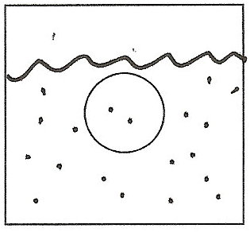
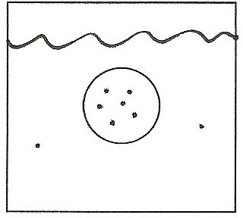
1. 2.

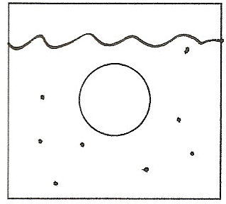
3. 4.

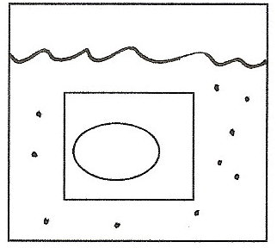
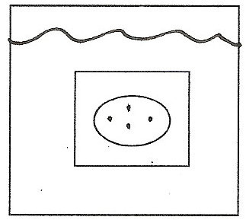
5. 6.

7-13 Answer the following questions using complete sentences.

7. Explain what happens to plant cells that are put in really salty water.

8. Explain what happens to animal cells that are put in really salty water.

9. Explain what happens to plant cells that are put in fresh water.

10. Explain what happens to animal cells that are put in fresh water.

11. Why don’t plant cells burst if a lot of water diffuses into them?

12. Salt water crabs have the same proportion of salt in their cells as the water that they live in. Considering this, what would happen to the cells of a crab if you put it in fresh water, why?

13. What would happen to the cells of a freshwater fish if you put it in salt water, why?

