Name: ______________________________________________ Period:___________

**Student Page**

**Title: Atmosphere 6-station lab**

**Procedures**: Six stations have been set up. Visit each one and follow the directions.

Record the data and answer the analysis and conclusion.

[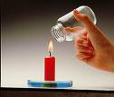](http://images.google.com/imgres?imgurl=http://www.dkimages.com/discover/previews/886/35058427.JPG&imgrefurl=http://www.dkimages.com/discover/Home/Science/Physics-and-Chemistry/Matter/Gases/Experiments/Experiments-046.html&h=360&w=424&sz=25&hl=en&start=1&um=1&tbnid=GGNH0eoizcx5TM:&tbnh=107&tbnw=126&prev=/images?q=jar+over+candle&ndsp=20&um=1&hl=en&rlz=1T4RNWO_en___US224&sa=N)

### **Station 1**

1. How long did the flame burn: Small Jar

Large Jar

1. Why did they burn at different rates?
2. What is the black stuff that accumulates on the bottom of the jar?
3. Why did water move up into the jar?

[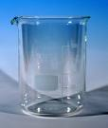](http://upload.wikimedia.org/wikipedia/commons/thumb/1/1f/Beaker_hg.jpg/507px-Beaker_hg.jpg)

**Station 2**

Part I

1. What happened to the air pressure when you tried to push the bag into the beaker?
2. Is the pressure higher inside or outside the bag?

Part II

1. What happened to the air pressure when you tried to pull the bag out of the beaker?

**Station 3**

[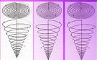](http://www.leyman.demon.co.uk/spiral,%20both%20types.gif)

1. What happened to the spiral, and WHY?
2. Describe a convection current.
3. When air is rising what kind of a pressure system does it create (High or Low)?
4. Name two other places you can find convection currents (related to Earth Systems)

**Station 4**

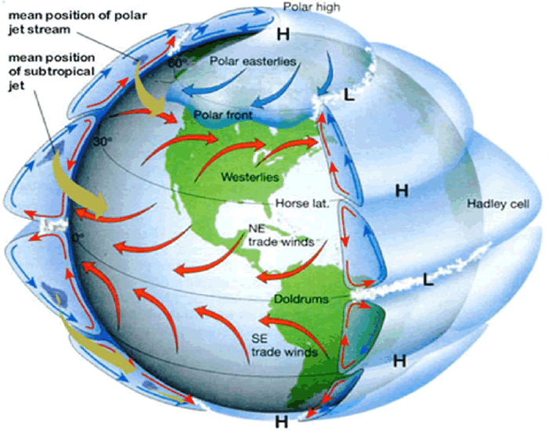

1. What way did the line curve when traveling from the North pole to the equator?
2. What way did the line curve when traveling from the South pole to the equator?
3. What is this effect called?
4. The movement of which substances are affected by the spinning Earth?

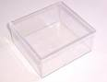

**Station 5**

1. What happened when the divider was removed?
2. Sketch:
3. Why?
4. Would air behave the same way? Why?



**Station 6**

1. What was created inside the jar when the paper burned?
2. What made the egg go into the jar?
3. What effect did blowing into the jar have?
4. 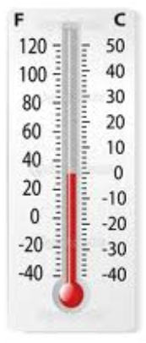Why?

**Station 7**

1. Did the temperature change when the pressurized gas came out of the pump?
2. Why?
3. How does this explain what happens to air when it rises?