Names _________________________ Date ___________ Period __________

The Holocaust: A Background
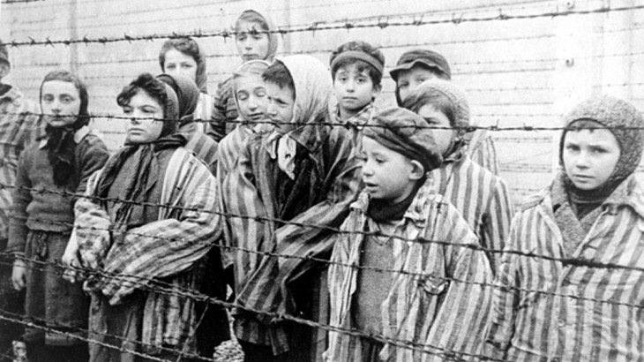

Directions:
Click on the following hyperlinks to help you complete the assignment. Parts II-VIII (Questions 2-16) will be covered in a series of videos found here or by clicking on the title of each section. Additional information about each of the questions can be found by clicking on the hyperlinks.

- Before Viewing: What is Genocide? | - The dictionary defines genocide as “the systematic killing of a racial or cultural group.” How does the United Nations define genocide?
- The Holocaust: | - What was the goal of the German Nazis during the events that came to be known as the Holocaust?
 | - How did the German Nazis see the Jews?
- The Nazi Rise to Power: | - When did the Nazis come into power in Germany?
 | - When the Nazis came into power how many millions of Jews were there worldwide? How many million in Europe?
 | - Describe how the Germans defined the Aryan race in your own words.
- Separation, Exclusion, and Expulsion: | - In November of 1938 the “Kristallnacht Pogrom” took place throughout Germany. What happened during Kristallnacht?
 | - What happened to most of the Jews who moved out of Germany?
- War and Territorial Expansion: | - What invasion started World War II? When did this happen?
 | - Ghettos were designed as “holding pens” for the Jews of Eastern Europe. On October 12, 1940, the Germans decreed the establishment of the Warsaw Ghetto. What did that decree require?
- “Operation Barbarossa” Systematic Murder Begins | - In what year did Germany break their peace treaty with the Soviets and invade the Soviet Union?
 | - Who did the Germans believe was responsible for the creation of communism?
- “The Final Solution” Coalesces | - Within their first six months in the Soviet Union, how many Jews had the Germans murdered?
 | - What was Zyklon B originally used for?
- Perfecting Industrial Murder: | - What is the name of the largest concentration camp and industrial killing center?
 | - What were the Death Marches out of Auschwitz?

