Food Plate
Kids InfoBits. 2016.
COPYRIGHT 2014 Gale, Cengage Learning
Full Text:
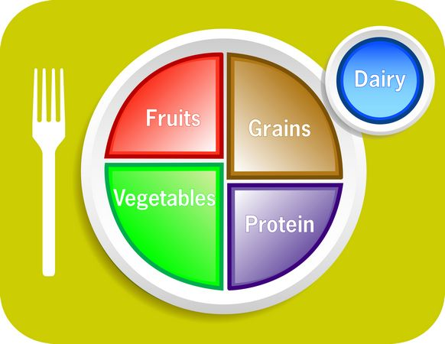

Food Plate Guide. Basheera Designs/Shutterstock
The food plate is known as MyPlate. It is a guide to healthy eating. The U.S. Department of Agriculture (USDA) makes it. MyPlate replaced the food guide pyramid in 2011. MyPlate shows people of all ages how to choose healthy foods.
MyPlate teaches people about portions. Portions are how much of a food people should eat. MyPlate teaches people that some foods, like vegetables, are healthier than others. This means that people should eat more vegetables.
The MyPlate picture shows five food groups. It is a round plate cut into four sections next to a glass. Each color on the plate and glass stands for a food group.
The glass is blue for dairy. Milk and cheese are dairy foods. Dairy contains calcium. Calcium makes the bones and teeth strong.
The biggest part of the plate is green for vegetables. This shows that people should eat more vegetables than the other food groups. Carrots and broccoli are vegetables. Vegetables have lots of vitamins and minerals. Vitamins and minerals are good for the body.
The next section of the plate is red is for fruits. Blueberries and oranges are some fruits. Fruits contain vitamins and fiber. Fiber helps to keep a person full. Vegetables and fruits fill up half of the plate.
One half of the plate is for grains and proteins.
Orange stands for grains. Bread and pasta are grains. Whole grains are healthier. They contain more fiber. Oatmeal and brown rice are some whole grains.
The last part is purple for protein. Beef and beans are some proteins. Protein helps the body build muscles. The grains section is larger than the protein section. This shows that people should eat more grains than protein.
Exercise is an important part of being healthy. Exercise makes a person’s muscles and bones strong. It helps people lose weight. It also helps keep their weight the same. Exercise helps protect the body from getting sick.
People should exercise most days of the week. Some types of exercise are walking, playing sports, and lifting weights.
Source Citation (MLA 8th Edition)
"Food Plate." Kids InfoBits, Gale, 2016. Kids InfoBits, go.galegroup.com/ps/i.do?p=ITKE&sw=w&u=pioneer&v=2.1&id=GALE%7CNWYUMS106669878&it=r&asid=70b55f58647c7213b72e829f6b2e8958. Accessed 6 Dec. 2016.
Gale Document Number: GALE|NWYUMS106669878

