Range of Reading and Text Complexity
Standard 10: Read and comprehend complex literary and informational texts independently and proficiently.
2nd Grade: By the end of the year, read and comprehend literature, including stories and poetry, in the grades 2-3 text complexity band proficiently, with scaffolding as needed at the high end of the range.
3rd Grade: By the end of the year, read and comprehend literature, including stories, dramas, and poetry, at the high end of the grades 2-3 text complexity band independently and proficiently.
4th Grade: By the end of the year, read and comprehend literature, including stories, dramas, and poetry, in the grades 4-5 text complexity band proficiently, with scaffolding as needed at the high end of the range.
5th Grade: By the end of the year, read and comprehend literature, including stories, dramas, and poetry, at the high end of the grades 4-5 text complexity band independently and proficiently.

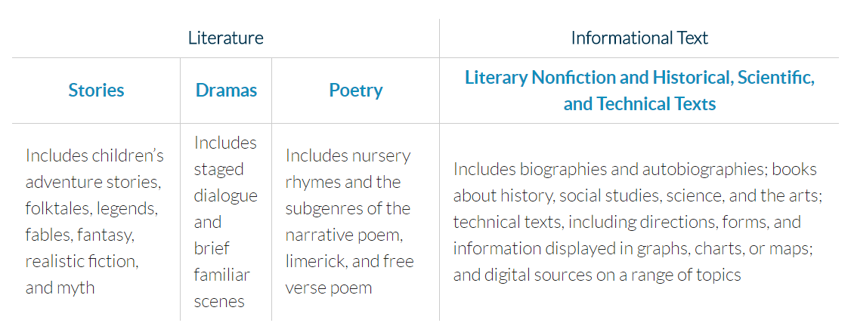

Text Complexity Grade Band in the Standards | Old Lexile Ranges | Lexile Ranges Aligned to College and Career Readiness Expectations
K-1 | N/A | N/A
2-3 | 450-725 | 450-790
4-5 | 645-845 | 770-980
6-8 | 860-1010 | 955-1155
9-10 | 960-1115 | 1080-1305
11-CCR | 1070-1220 | 1215-1355

