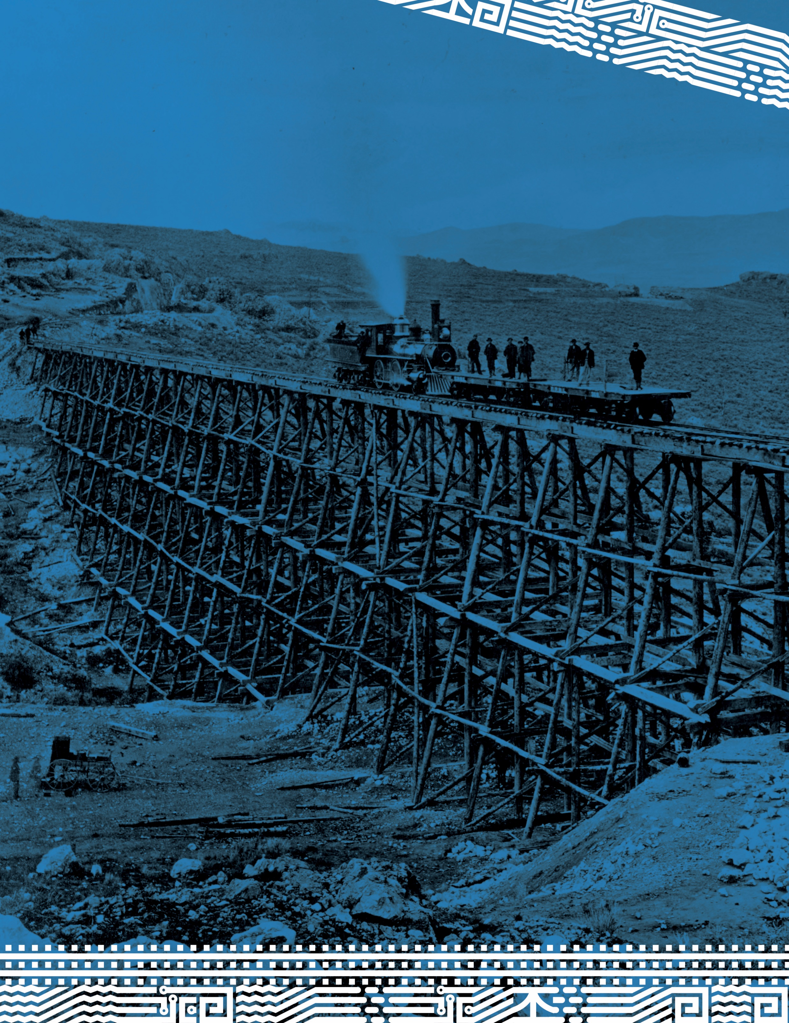

Ogden & Corinne:
Two Utah Cities Changed
by the Transcontinental Railroad

GRADE 8
Ogden & Corinne: Two Utah Cities Changed by the Transcontinental Railroad
By Aaron L. Crawford
Summary
Students will compare the cities of Ogden and Corinne, both before and after the transcontinental railroad was built. To create their comparison, students will analyze primary documents and refer to secondary documents.
Main Curriculum Tie
US History Standard: 5 Objective: 3 – Students will make a case for the most significant cultural, political, and economic impacts of territorial and/or industrial expansion.
Additional Curriculum Ties
US History Standard: 6 Objective: 3 – Students will identify the economic and geographic impact of the early Industrial Revolution’s new inventions and transportation methods, such as the . . .transcontinental railroad.
English/Language Arts 8 – Informational Text Standard: 9 – Analyze a case in which two or more texts provide conflicting information on the same topic and identify where the texts disagree on matters of fact or interpretation.
Time Frame
Approximately 60 minutes. While the lesson was designed for one class period, it could be broken into different section (e.g. two 30 minute time periods).
Group Size
You could use this lesson plan with individuals, partners, or small groups.
Life Skills
_ Aesthetics _ Character _ Communication _ Employability
_ Social & Civic Responsibility X Systems Thinking X Thinking & Reasoning
Bibliography
Huefner, Michael. "Engines of Change: Railroads in Utah." 2018. Our Past, Their Present: Teaching Utah with Primary Sources.
Madsen, Brigham D. and Betty M. Madsen. "Corinne, The Fair: Gateway to Montana Mines." Utah Historical Quarterly 37.1 (1969): 103-123. <http://utahhistory.sdlhost.com/#/item/000000031000371/view>.
Strack, Don. "Ogden Rails: a History of Railroading at the Crossroads of the West." Cheyenne: Union Pacific Historical Society, 2005. 7 July 2018. <http://utahrails.net/ogden/ogden-utah-northern.php>.
U.S. National Archives and Records Administration. Document Analysis Worksheets. 3 March 2017. 6 July 2018. <https://www.archives.gov/education/lessons/worksheets>.

Materials
You’ll need the following documents from Huefner’s Engines of Change: Railroads in Utah (These are attached at end of lesson. These page numbers are from the original document. See the Instructions Procedures section for pagination in this lesson plan):
- Maps of Ogden (p. 23-24)
- Photographs of Ogden and Corinne (p. 21-22, 27-28)
- Map Series: Railroads Spread throughout Utah (p. 7-9)
- Ogden and Corinne: Two Railroad Towns (p. 4-5)
Background for Teachers
Your students will discover most of this information as they examine the documents in this lesson. I suggest you not read it to them before that.
Ogden and Corinne are two cities in Utah that were profoundly affected by the growth of railroads in Utah and the transcontinental railroad in particular.
Corinne, a small town about ten miles west of Brigham City, currently has a population with more cows than people. However, at the time of the transcontinental railroad it was fast becoming a major city. Corinne’s primary business was hauling goods north from Utah into Idaho and Montana. Alternate routes were difficult to navigate, giving Corinne an advantage over its neighbors. As you can imagine, the transcontinental railroad only helped the shipping business and Corinne became a major stop on the railroad line. Two things worked together to stop the city’s prosperity: First, additional railroad lines were completed, which circumvented Corinne as a major stop. Second, the Lucin Cutoff, a railroad trestle across the Great Salt Lake, was completed in 1904. Corinne was no longer on the major line, resulting in it becoming a very small town.
Ogden’s story is almost perfectly in contrast with Corinne’s – each of the events that damaged shipping in Corinne helped Ogden’s shipping economy. The railroad lines that went north all converged in Ogden. The Lucin Cutoff cut straight across the lake to Ogden. And so as Corinne shrank, Ogden grew.
Comparing the two cities reveals the enormity of the impact the railroad plays on local economies.
Student Prior Knowledge
Students should be generally familiar with the cultural and economic importance of the transcontinental railroad.
Intended Learning Outcomes
Students will explain how the transcontinental railroad impacted the local communities of Utah by examining Ogden and Corinne as case studies. Students will note that, as the railroad was completed, cities prospered, and then the route change due to the Lucin Cutoff further altered both cities.
Instructional Procedures
The students will discover what happened to Corinne and Ogden as a result of the transcontinental railroad. They will uncover the results as they examine primary documents. Don’t tell them what happened to the cities until after they have read all of the documents.
Explain that Corinne and Ogden are both cities in Utah. Both were involved in the shipping industry. They are about 30 miles apart. If your students are unfamiliar with that region, you may want to show them the cities on a map.
Distribute the Student Worksheet (p. 5-6).
You will need to hand the documents out in the order listed below, one at a time, pausing between each document to give students time to answer the questions on the paper.

Here is the order:
- Maps of Ogden (p. 7-8)
- Photograph of Ogden, c. 1863-1865 (p. 9)
- Photograph of Corinne, 1870 (p. 10)
- Photograph of Ogden, 1900 (p. 11)
- Photograph of Corinne, 1940 (p. 12)
- Railroads Spread throughout Utah maps (p. 13-15)
- Reading: Engines of Change - Ogden and Corinne: Two Railroad Towns (p. 16-17)
You may choose to use the last few questions as discussion questions instead of having the students answer them individually.
Strategies for Diverse Learners
Since the majority of the primary documents are photographs, the lesson should be fairly accessible. You may need to explain the questions on the student worksheet to special education or ELL students. Students may also need help interpreting maps.
Extensions
Students could use the internet to research additional information on Ogden and Corinne. Searching Ogden Utah History or Corinne Utah History yields many fascinating results that may help add color to what the students have learned.
Assessment Plan
The student worksheet can serve as the assessment plan.

Student Worksheet: Ogden & Corinne

Name:

Maps of Ogden
- How are these two maps different?

- Why do you think Ogden changed so much between those years?

Photograph of Ogden, c. 1863-1865
- List the things you see. Anything you notice in the photograph can go into this list. (The more things you write here, the easier the rest will be). Be sure to look at all of the parts of the photograph.

- Choose one of the things you noticed (circle it in the list above). What does that thing tell you about Ogden in this time period?

Photograph of Corinne, 1870
- List the things you see. Anything you notice in the photograph can go into this list. (The more things you write here, the easier the rest will be).

- Choose one of the things you noticed (circle it in the list above). What does that thing tell you about Corinne in this time period?

- Compare the cities of Ogden and Corinne in these two photographs.

Photograph of Ogden, 1900
- How has Ogden changed since 1900? Give specific details contrasting this photograph with the older photograph of Ogden.

Photograph of Corinne, 1940
- How has Corinne changed since 1900? Give specific details contrasting this photograph with the older photograph of Corinne.

- Compare the cities of Ogden and Corinne in these two photographs.

Railroads Spread throughout Utah
- Compare the maps of the railroads. What railroad lines were added over time? Why do you think those were added?

- Read the pages from Engines of Change. How accurate was your explanation in question 12?

- After what you’ve read, write a brief explanation of what happened to Ogden and Corinne.

- What additional information does Engines of Change provide that you could not get from the primary documents?

- Why was the railroad an “engine of change?” Give specific examples.

- In what ways could the railroad make or break a community’s fortunes?
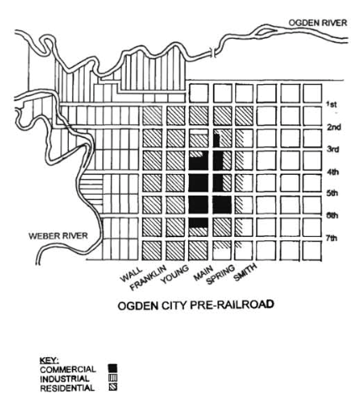

Map A: Ogden, Utah, ca. 1870

Source: Map by Gordon Turley, in Jalynn Olsen, Building by the Railyard: The Historic Commercial and Industrial Architecture of Ogden, Utah (Graduate School of Architecture, University of Utah, 1998). https://collections.lib.utah.edu/details?id=418969

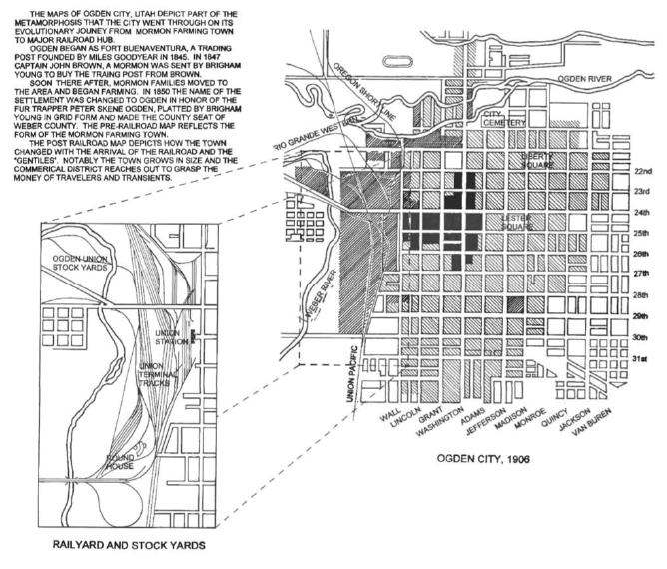

Map B: Ogden, 1906

Source: Map by Gordon Turley, in Jalynn Olsen, Building by the Railyard: The Historic Commercial and Industrial Architecture of Ogden, Utah (Graduate School of Architecture, University of Utah, 1998).

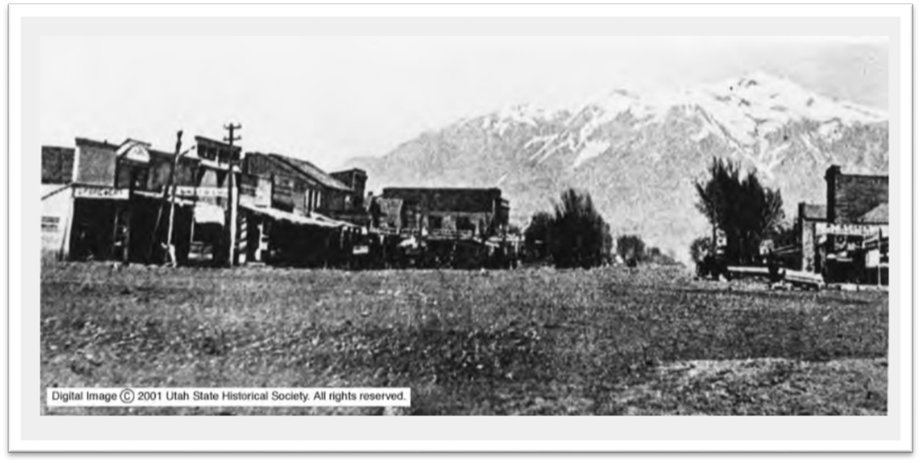

Photo: Ogden, Utah, near Washington Avenue, ca. 1863-1865

Source: “Ogden, Utah P. 11,” ca. 1863-1865, Utah State Historical Society Classified Photo Collection. https://collections.lib.utah.edu/details?id=453263

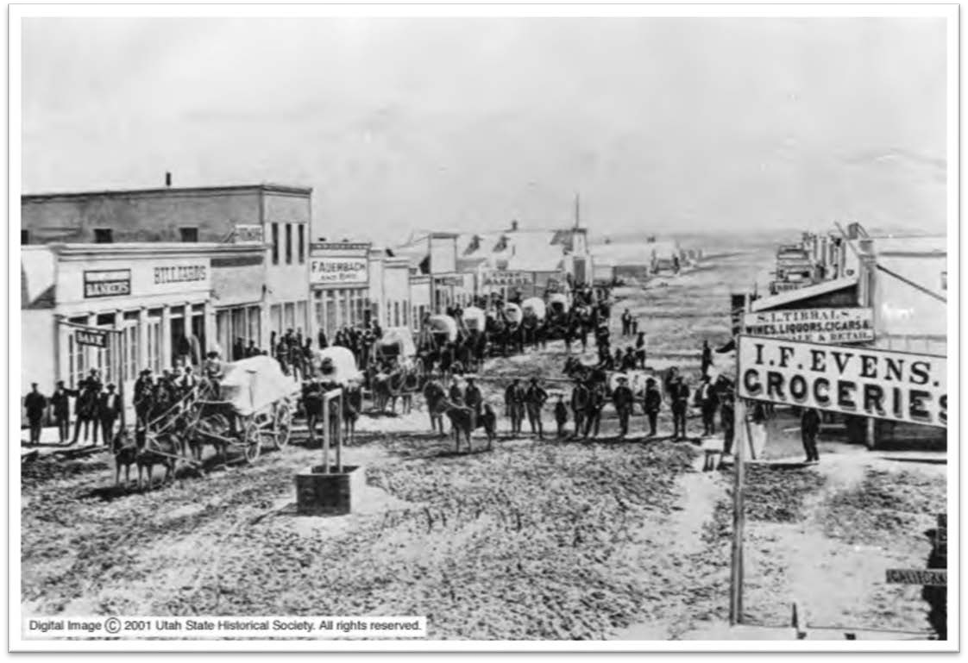

Photo: Corinne, Utah, 1870

Source: “Corinne, Utah p.2” Corinne businesses, 1870, Utah State Historical Society Classified Photo Collection, MSS C 239. https://collections.lib.utah.edu/details?id=452653

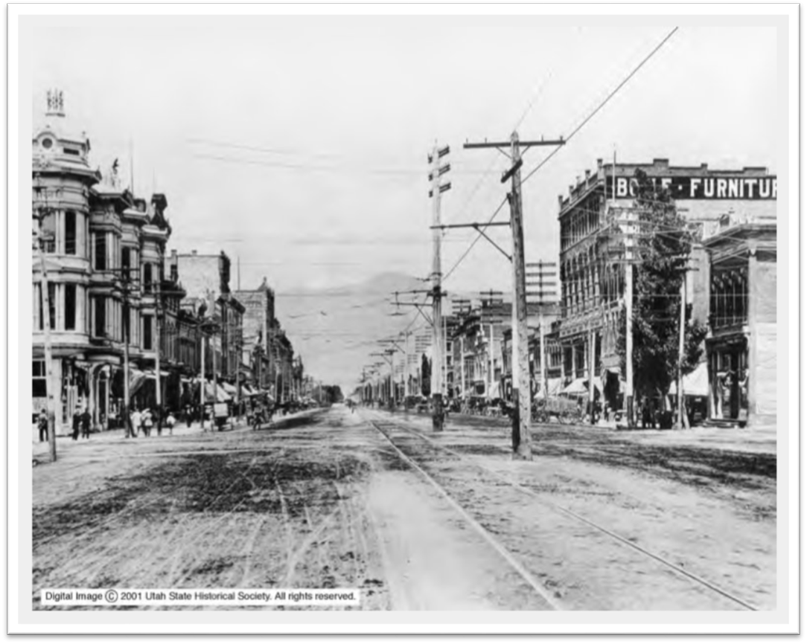

Photo: Ogden, Utah, near Washington Blvd., 1900

Source: “Ogden, Utah-Washington Blvd. P. 13,” 1900. Utah State Historical Society Classified Photo Collection. https://collections.lib.utah.edu/details?id=453326

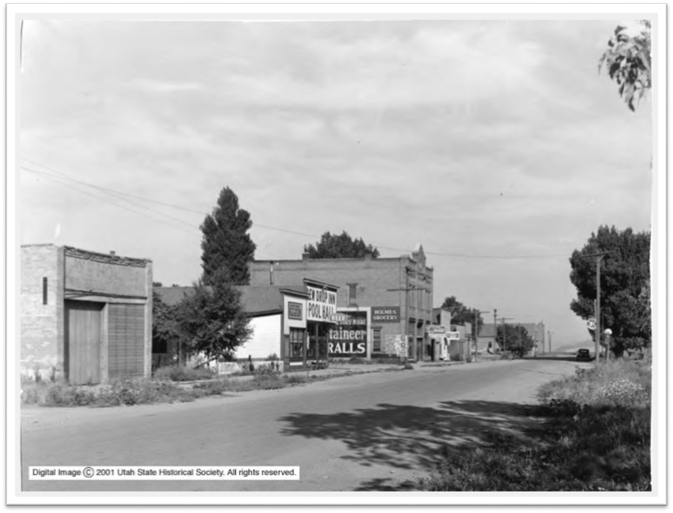

Photo: Corinne, Utah, Main Street, 1940

Source: “Corinne, Utah p. 1,” Corinne Main Street, 1940, Utah State Historical Society Classified Photo Collection. https://collections.lib.utah.edu/details?id=452663

MAP SERIES: RAILROADS SPREAD THROUGH UTAH, 1869-1920
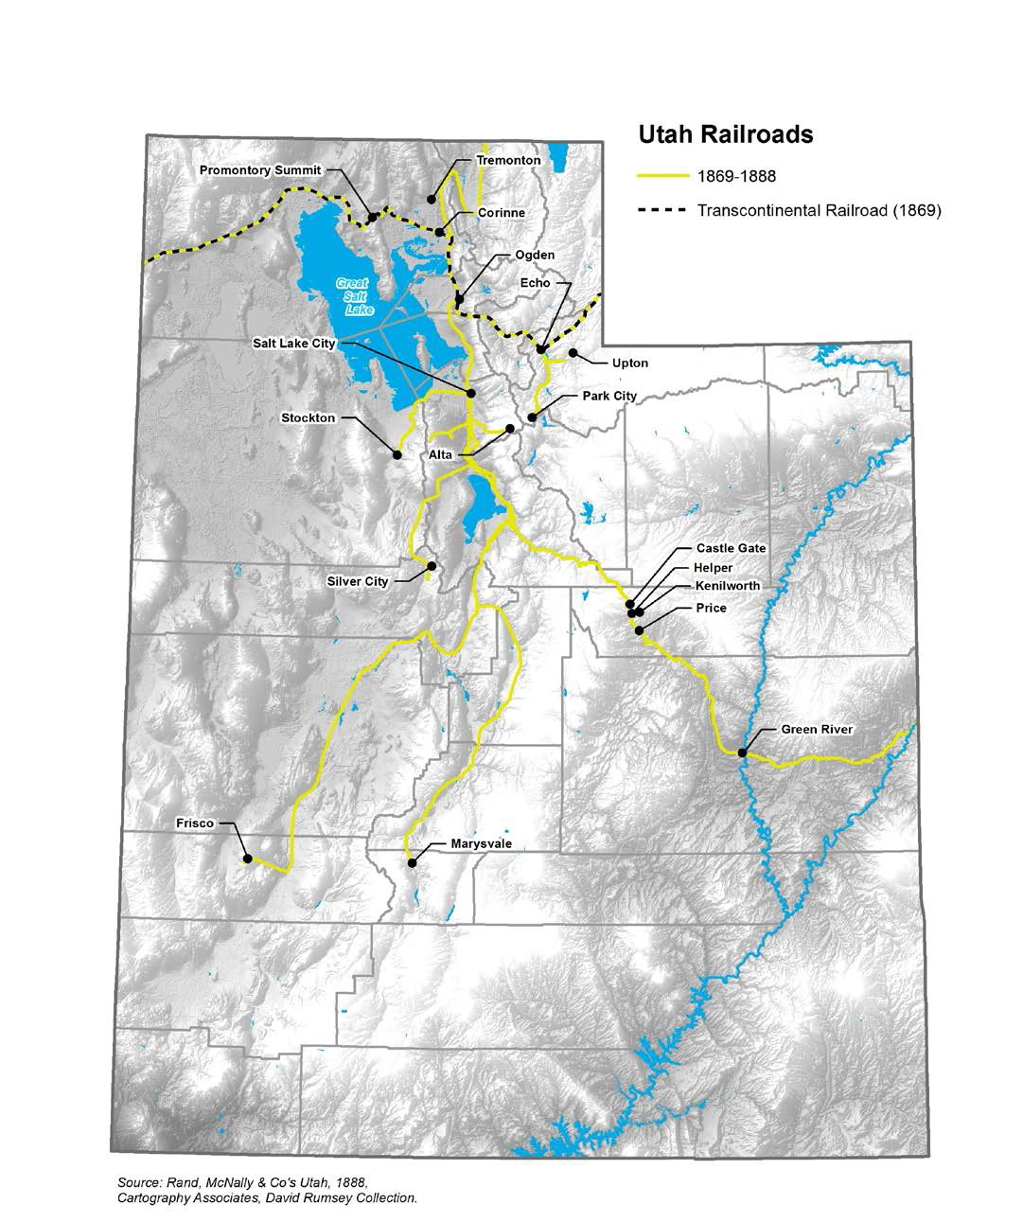

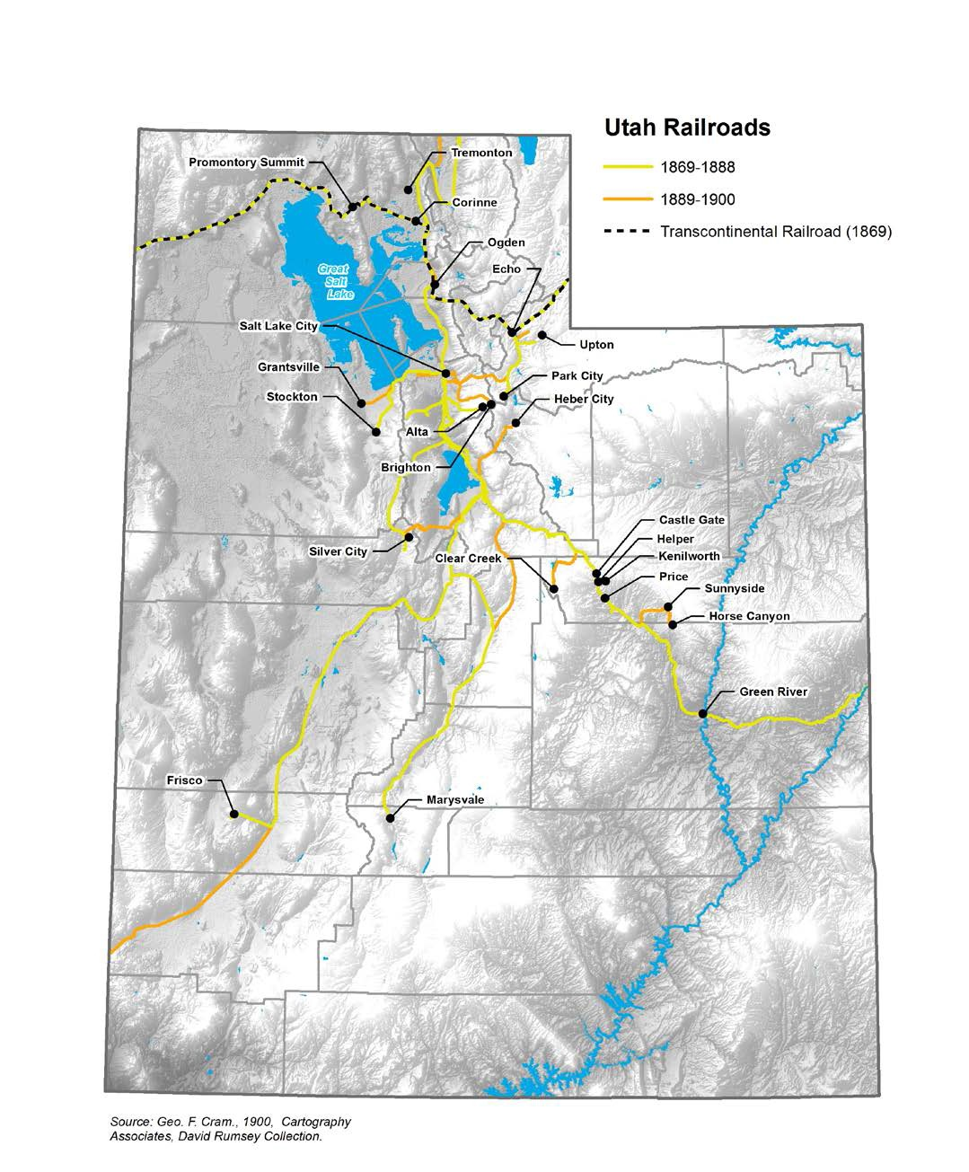
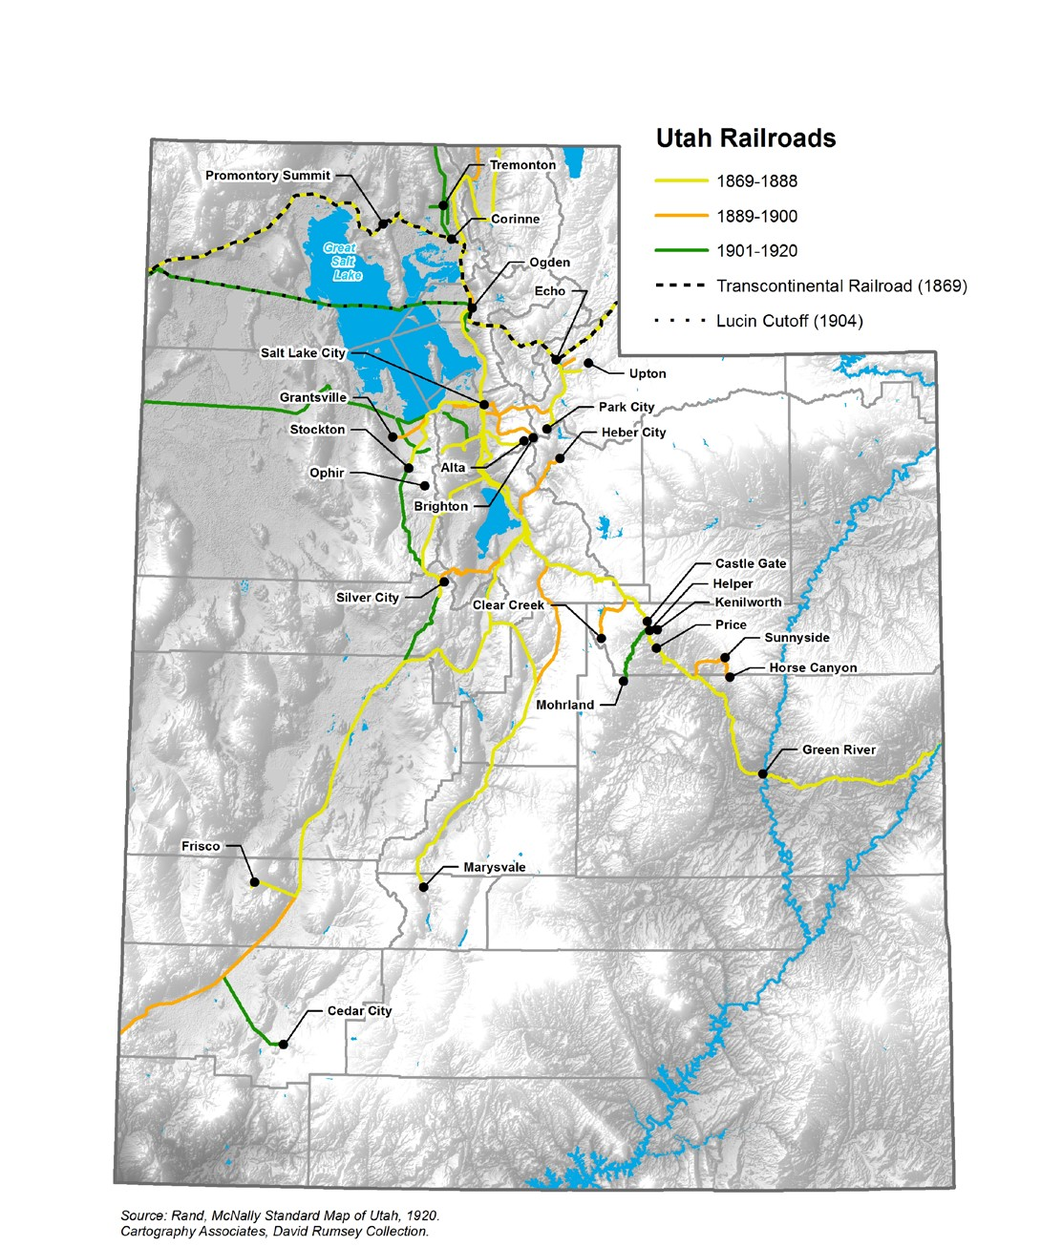

Ogden and Corinne: Two Railroad Towns

When the transcontinental railroad crossed through northern Utah, it spurred the hopes of many towns, but two that were greatly affected were Ogden and Corinne.
Ogden began as a small Mormon farm town, but after the Union Pacific arrived Ogden began to grow. Travelers in the 1870s would have seen small, hastily built buildings near the railroad stations including restaurants, taverns, and gambling houses. Beyond this remained a fairly quiet town that supplied most of its own needs through small shops, gristmills, and surrounding farms. Ogden’s fortunes changed again in 1874, when the Union Pacific and Central Pacific made it the junction where passengers and freight were transferred between the two lines. Ogden’s population surged from 3,000 in 1870 to more than 12,000 in 1890. A large new rail depot was completed in 1889, the same year the town elected its first non-Mormon mayor.
Corinne was also an important place of trade in 1870. Lying at the connection of the Bear River and the railroad line, Corinne’s overland freight trade carried goods and ores between Montana mines and the transcontinental railroad. Chinese railroad workers settled there and established businesses, such as laundries and restaurants. Two dance halls and three churches were built, including the 1870 Methodist-Episcopal Church, the oldest Protestant church in the state. The railroad brought many tourists and curious observers, and Corinne’s reputation for excitement brought people from neighboring towns to dances, sporting events, and dramatic performances at the opera house. Corinne’s non-Mormon founders hoped it would become the cultural and economic center of Utah.
But during the 1870s a new rail line allowed Ogden to cut into Corinne’s freight business. The Utah Northern Railroad, reaching north from Brigham City to Franklin, Idaho, soon absorbed Corinne’s lucrative Montana trade. By the decade’s end most of the jobs and people in Corinne had left seeking better opportunities.

The Lucin Cutoff

In 1904 Corinne’s fate was sealed when the Southern Pacific Railroad (formerly the Central Pacific) completed the Lucin Cutoff. This bypassed the old Transcontinental route from the West Desert to Ogden by carrying trains directly across the Great Salt Lake. This ambitious project built a trestle system across twelve miles of open water. The trestles “were constructed by establishing stations at each mile end of the route and setting two pile-drivers to work back to back. The workmen were quartered right on the site ‘well out of the way of storm-waves’ in a boarding house resting on a platform supported by piles. For this privilege the men paid four dollars a week each, but supplies and cooks were free,” (Dant).
Work crews lived away from many comforts and without days off. The lake’s extremely salty water was so heavy (seventy-six pounds per cubic foot) that storm waves could damage the trestle and move the massive boulders supporting it.
After the Lucin Cutoff opened, the railroad completely bypassed Corinne, and without this economic pillar the town withered.

Rails and Mines Grow Hand in Hand

Colonel Patrick Connor, commander of the U.S. Army’s Camp [Fort] Douglas above Salt Lake City, played a critical role in the growth of Utah’s railroads. Connor’s official job was to keep mail routes safe, but he harbored strong concerns about the Mormons’ monopoly over goods and resources in Utah. To counter this, Connor worked to promote immigration.
Connor saw the discovery of valuable minerals as the key to this plan, so he sent prospectors throughout the territory. When they found gold, silver, and other useful minerals it took the mining industry in Utah to new heights. This in turn fueled the spread of railroads and, as Connor hoped, brought thousands of ethnically and religiously diverse immigrants to Utah.
The Union Pacific and Southern Pacific continued to build rails across the state in the 1870s, especially into the mining districts. In the 1880s the Denver & Rio Grande (D&RG) Railroad connected the coal district of Price, Helper, Kenilworth, and Castle Gate to the string of settlements along the Wasatch Mountains. Thanks to the D&RG coal mining became an economic mainstay in Utah. These coal-mining towns expanded quickly, and Carbon County was organized in 1894. Like most mining areas in Utah Carbon County attracted a diverse population of workers and their families, especially from Italy, Greece, Finland, and Great Britain. As industry increased immigration continued, bringing a kaleidoscope of cultures to mining towns like Kenilworth across the state.
Many Americans might not have felt the impact of the transcontinental railroad immediately, but Utahns quickly experienced the changes. From a desert outpost to a crossroads, a Native homeland to a conglomeration of new settlements, the railroads set Utah’s evolution toward modernity in motion. Well into the 1950s, railroads would remain the best mode for interstate passenger travel as well as freight. Even in the 21st century, trains play a critical role in Utah’s industrial economy.
Sources

Thomas G. Alexander, Utah, The Right Place: The Official Centennial History, SLC: Gibbs Smith, 1995; Leonard Arrington, “The Transcontinental Railroad and the Development of the West,” Utah Historical Quarterly 39, no. 1 (Winter 1969): 3-15, https://collections.lib.utah.edu/details?id=421779; “Chinese American Contribution to Transcontinental Railroad,” Central Pacific Railroad Photographic History Museum, June 2017, http://cprr.org/Museum/Chinese.html; “The Civil War: Facts,” NPS.gov, https://www.nps.gov/civilwar/facts.htm; Jennifer Fisher, et al., “Building the First Transcontinental Railroad,” Digital Public Library of America, May 2015, https://dp.la/exhibitions/exhibits/show/transcontinental-railroad; Dean May, Utah: A People’s History, Salt Lake City: University of Utah Press, 1987; Brigham D. Madsen, “Frolics and Free Schools for the Young Gentiles of Corinne,” Utah Historical Quarterly 48, no. 3 (Summer 1980): 220-233, http://utahhistory.sdlhost.com/#item/000000031000684/view/1; Jalynn Olsen, Building by the Railyard: The Historic Commercial and Industrial Architecture of Ogden, Utah (Graduate School of Architecture, University of Utah, 1998). https://collections.lib.utah.edu/details?id=418969; J. Weston Phippen, “‘Kill Every Buffalo You Can! Every Buffalo Dead Is An Indian Gone,’” The Atlantic, May 13, 2016, https://www.theatlantic.com/national/archive/2016/05/the-buffalo-killers/482349/; Don Strack, “Railroads in Utah,” Utah History to Go, 1994, http://historytogo.utah.gov/utah_chapters/mining_and_railroads/railroadsinutah.html; “Timeline,” Chinese Railroad Workers in North America Project at Stanford University, http://web.stanford.edu/group/chineserailroad/cgi- bin/wordpress/timeline/#fn33. Doris R. Dant, “Bridge: A Railroading Community on the Great Salt Lake,” Utah Historical Quarterly 53, no. 1 (1985): 56-59. https://collections.lib.utah.edu/details?id=423033.

Utah Territory Settler Population: Changing Religious & Ethnic Demographics

Year | Settler Population | Mormons | Other Religious/Ethnic Groups
1860 | 40,273 | 92% | 8%
1869 | Railroads Arrive in Utah
1870 | 86,786 | 92% | 8%
1880 | 143,963 | 79% | 21%
1890 | 210,779 | 66% | 34%
Data from the U.S. Census, May, Utah: A People’s History, p. 116, and Alexander, Utah: The Right Place, p. 140.

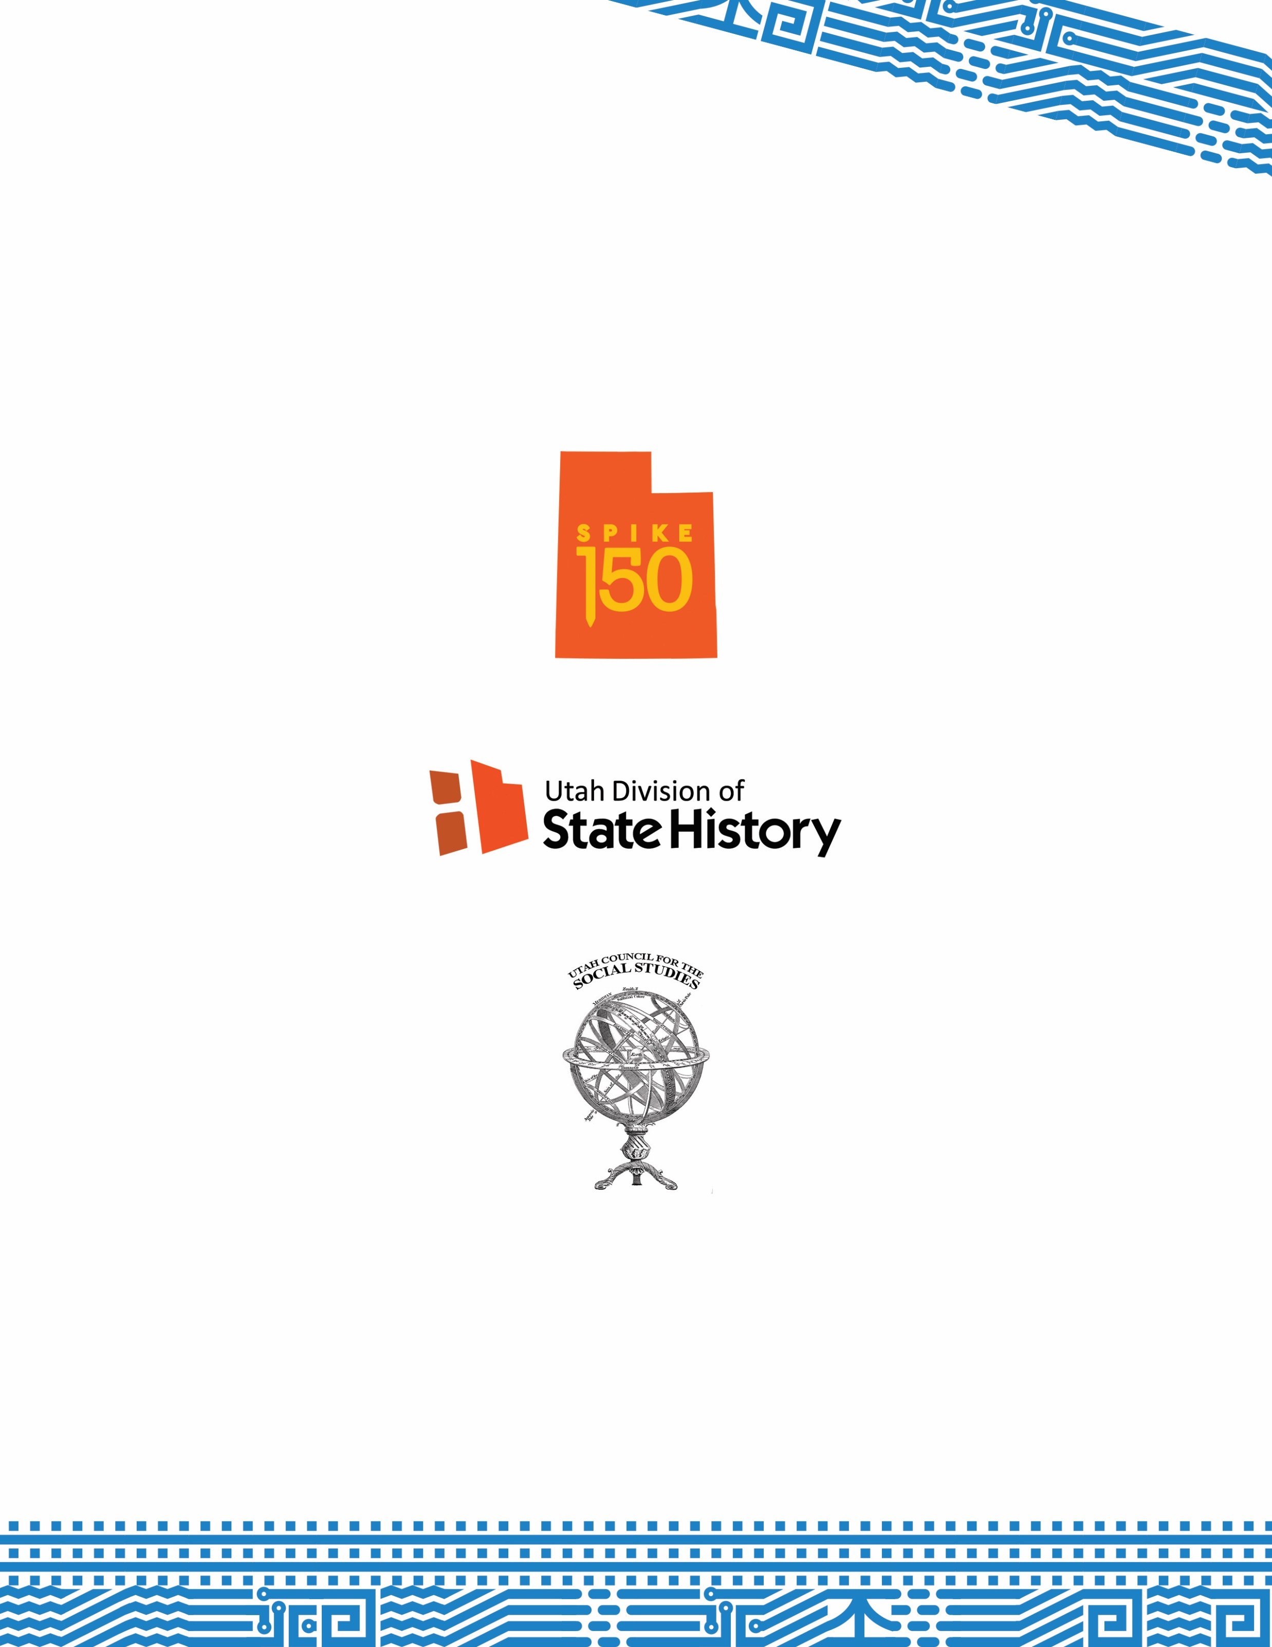
Lesson plans on the Transcontinental Railroad created with the support of Spike150, the Utah Division of State History, and Utah Council for the Social Studies.

