UEN Lesson Plan Tool
www.uen.org/lessonplan

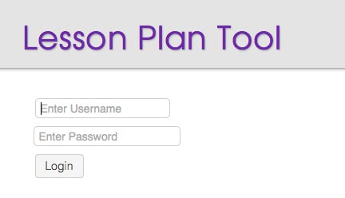
- 1 - Login

To create a new lesson plan or edit an existing lesson plan, visit www.uen.org/lessonplan and enter your my.uen username and password. To create a my.uen account visit https://my.uen.org.

- 2 - Create / Edit a Lesson Plan

To create a new lesson plan, use the CREATE button, enter a title and then use the OK option. You will be able to edit the title later if you need to.

To edit on an existing lesson plan, use the pencil icon or click on the lesson plan title.

Use the trashcan icon to permanently delete the lesson plan.
- 3 - Add Lesson Plan Content

The lesson plan edit screen has three main sections: General, Instructional and Assessment. Each section has a variety of categories, such as core ties, materials and extensions. You can skip any category that does not fit your plan.

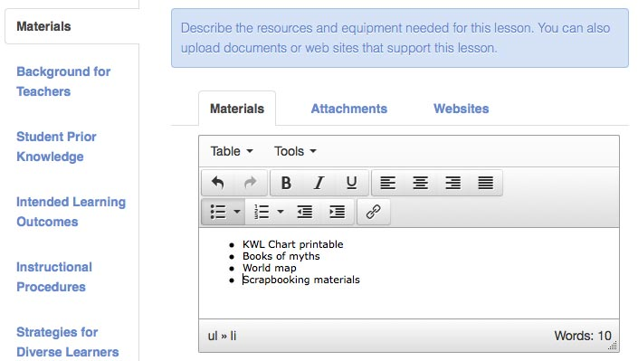
In addition to descriptive text, many of the categories allow you to add attachments and websites.

Every lesson plan can have multiple authors which makes collaboration easy. All authors must be registered with the Utah Education Network. (https://my.uen.org ) Use the Authors option in the General section to add an author.

- 4 - Save and Preview
The lesson plan tool has auto-save functionality, but you can also manually save your work by using the SAVE button at the top of the screen. The SAVE AND EXIT button will return you to the My Lesson Plans screen after saving your work to the database.

The PREVIEW button allows you to see what the lesson plan looks like to the public. You can find your lesson plan’s unique website address (e.g. https://www.uen.org/lessonplan/view/_____) from this browser window, as well as a link to a Printable Version of your plan.

- 5 - Associate Rubrics

In addition to a description of your assessment plan, you can create and associate a rubric to your lesson plan. Go to the Assessment section of the lesson plan tool and use the Rubrics option. If you have not previously created a rubric using the UEN Rubric Tool, use the UEN RUBRIC TOOL button and that will take you to the Rubric Tool edit interface.

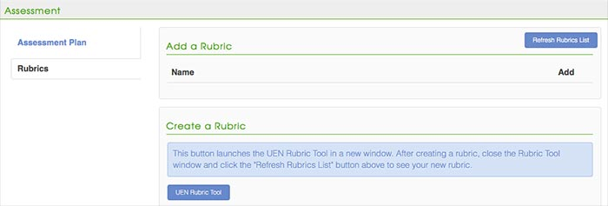
After you create a rubric, return to the Assessment screen and use the REFRESH RUBRICS LIST button if you do not see your rubric. Use the Add (+) option next to rubric title to associate your rubric to your lesson plan.

